

Trajectory Prediction and Bird’s Eye View Generation from Surround View Fisheye Camera Images for Automated Driving

LK480 - Master of Engineering in Edge Computing

Final Project Report

Allwin Martin Bodi Gadda
24221384

Dr. Mark Halton

22nd August 2025

Abstract
The increasing need for safe and reliable autonomous driving systems has been driving the need for precise ego vehicle trajectory prediction. Conventional approaches with LiDAR and radar provide high accuracy but are expensive, computationally intensive, and hard to scale up, while fisheye surround-view cameras provide a cheaper and broad-coverage solution but are plagued by geometric distortions that make precise prediction difficult. To overcome this limitation, this project designed an end-to-end regression-based system combining fisheye-to-Bird's Eye View (F2BEV) transformation and Long Short-Term Memory (LSTM) networks. The developed pipeline consisted of fisheye image capture, distortion correction, BEV generation, ego vehicle coordinate extraction, and time-series preparation. With the Volvo FB-SSEM dataset, the LSTM model was trained and tested with Mean Squared Error (MSE) and Mean Absolute Error (MAE) to estimate prediction accuracy. Experiments revealed that BEV transformation effectively rectified distortions and produced spatially consistent maps, while the LSTM model effectively captured temporal relationships and generated smooth and precise predictions for future (X, Y) positions. Experiments proved that regression-based forecasting offered greater granularity and reliability compared to classification-based methods, and thus was more applicable for real-time trajectory prediction. This work makes a cost-efficient, scalable, and explainable model for autonomous navigation safety and improves vision-based regression model understanding.
Keywords: Autonomous driving, trajectory prediction, fisheye cameras, Bird’s Eye View (BEV), LSTM regression

Declaration
This final report is presented in part fulfilment of the requirements for the LK480 Master of Engineering in Edge Computing (delete as appropriate) Masters Project.
It is entirely my own work and has not been submitted to any other University or Higher Education Institution or for any other academic award within the University of Limerick.
Where there has been made use of work of other people it has been fully acknowledged and referenced.

Name | ALLWIN MARTIN BODI GADDA
Signature | Allwin Martin
Date | 22nd August 2025

Acknowledgement
I would like to extend my heartfelt gratitude to several individuals whose guidance and support have been instrumental in the successful completion of this project.
First and foremost, my deepest thanks go to my Project Supervisor, Dr. Mark Halton, whose expertise, patience, and insightful feedback have been invaluable throughout this journey. His encouragement and guidance greatly enriched the quality of my work and helped me stay focused on the project objectives.
I am also sincerely grateful to Shusil Sharma, whose support during team meetings and valuable inputs contributed significantly to shaping my ideas and overcoming challenges. His practical suggestions and collaborative spirit made this work more meaningful.
Additionally, I would like to express my appreciation to my friends and family for their continuous encouragement and support. Their understanding during difficult times gave me the strength and motivation to persevere.
Finally, I acknowledge my peers and colleagues for their thoughtful discussions and constructive feedback during different stages of this project. Their perspectives helped me refine my approach and broaden the scope of my work.
Thank you all for your invaluable support and for believing in the vision of this project. Your collective wisdom and encouragement have been pivotal to its success.

Table of Contents

Abstract ii
Declaration iii
Acknowledgement iv
Table of Contents v
List of Figures viii
List of Tables ix
Chapter 1: Introduction 1
1.1 Overview 1
1.2 Motivation for the project 2
1.2.1 Global Need for Advanced Trajectory Prediction 3
1.2.2 Technical Rationale 3
1.3 Project aims and objectives 3
1.3.1 Aim 3
1.3.2 Objectives 4
1.4 Related Problem Context 4
1.4.1 Perception Challenges in Urban Driving 4
1.4.2 Regression vs. Classification in Motion Prediction 4
1.4.3 BEV Advantages 5
1.5 Report outline 5
1.6 Conclusion 6
Chapter 2: Literature review 7
2.1 Overview 7
2.2 Overview of Trajectory Prediction in Autonomous Vehicles 8
2.3 Review of Existing Trajectory Prediction Approaches 9
2.4 Evolution of Surround-View Systems in Autonomous Driving 12
2.5 Camera, LiDAR, and Radar in Vehicle Detection and Tracking 14
2.6 Robustness Analysis of BEV Models in Real-World Conditions 18
2.7 Research Gap 19
2.8 Conclusion 20
Chapter 3: Analytical Background 22
3.1 Overview 22
3.2 Regression Modeling Principles 22
3.2.1 Mathematical Formulation 23
3.2.2 Time-Series Regression 23
3.2.3 LSTM for Regression 23
3.3 Camera-Based Sensing in Autonomous Driving 24
3.3.1 Overview of Camera-Based Sensing 24
3.3.2 Surround-View Fisheye Cameras 24
3.3.3 Data Flow in Vision-Based Systems 24
3.4 Bird’s Eye View (BEV) Transformation 25
3.4.1 F2BEV Model Pipeline 25
3.4.2 Role of Segmentation in BEV 26
3.5 Coordinate Extraction for Regression Input 26
3.5.1 Bounding Box Detection in BEV 26
3.5.2 Center Coordinate Calculation 26
3.5.3 Dataset Preparation Using FB-SSEM 26
3.6 Evaluation Metrics for Trajectory Prediction 27
3.6.1 Mean Squared Error (MSE) 27
3.6.2 Mean Absolute Error (MAE) 27
3.7 Conclusion 28
Chapter 4: Specification and design 29
4.1 Overview 29
4.2 System Architecture 29
4.2.1 F2BEV Module 30
4.2.2 Coordinate Extraction Module 30
4.2.3 Trajectory Prediction Module (LSTM) 31
4.2.4 Visualization Module 31
4.3 Data Collection 31
4.4 Data Preprocessing 32
4.4.1 Spatial Preprocessing 32
4.4.2 Object Extraction 32
4.4.3 Feature Extraction 32
4.4.4 Temporal Sequence Preparation 33
4.4.5 Sequence Preparation for Trajectory Prediction 33
4.5 Model Design 33
4.5.1 Rationale for LSTM in Trajectory Prediction 34
4.5.2 Model Architecture 36
4.6 Loss and Optimization 37
4.7 Conclusion 37
Chapter 5: Implementation 39
5.1 Overview 39
5.2 Development Environment 39
5.3 Implementation of modules 40
5.3.1 Dataset Preprocessing Module 40
5.3.2 BEV Generation Module 40
5.3.3 LSTM Prediction Module 41
5.3.4 Trajectory Visualization Module 41
5.3.5 Demonstration Workflow 41
5.4 Conclusion 41
Chapter 6: Result and Discussion 42
6.1 Overview 42
6.2 Discussion 47
Chapter 7: Conclusion and Future Work 48
7.1 Overview 48
7.2 Conclusion 49
7.3 Limitation 49
7.4 Future work 50
References 51
APPENDIX 1: CODE LISTING……………………………………………………………………………………………….55
APPENDIX 2: WEEKLY PROGRESS REPORTS……………………………………………………………………………67

List of Figures
Fig. ‎4-1: Proposed Workflow for Ego Vehicle Trajectory Prediction 30
Fig. ‎4-2: LSTM Cell Structure for Ego Vehicle Trajectory Prediction 35
Fig. ‎6-1: Normalized Depth Ranges Categorized into Semantic Classes. 43
Fig. ‎6-2: Segmentation Model Evaluation Across Depth Ranges. 44
Fig. ‎6-3: Confusion Matrix. 45
Fig. ‎6-4: Ego Vehicle Trajectory Prediction. 45
Fig. ‎6-5: BEV segmentation of vehicles and obstacles. 46
Fig. ‎6-6: BEV-Based Trajectory Forecasting. 46

List of Tables
Table ‎5-1: Implementation Setup for Ego Vehicle Trajectory Prediction. 39
Table ‎6-1: Depth Classes for Ground Truth Segmentation 42
Table ‎6-2: Model Evaluation Metrics 43
Table ‎6-3: Confusion Matrix of Predicted vs. Ground Truth Segmentation 44

Introduction

Overview
Advanced sensing, perception, and decision-making technologies have sparked a revolution in the automotive industry by allowing the implementation of autonomous driving systems [1]. The development of autonomous vehicles (AVs) is turning into a reality no longer a conceptual vision, with research studies, pilots, and commercial tests being ramped up around the world. Their smooth and secure operation is dependent on their abilities to detect the surrounding environment, understand dynamical interactions, and forecast future conditions of the ego vehicle and the objects around it [2].
Trajectory prediction - the process of predicting the future location of a vehicle based on its motion history and sensor readings and surrounding context - is one of the most significant skills in this context [3]. Precise trajectories may be predicted to enabling an AV to make safe maneuvers, optimal route planning, and collision avoidance via pre-reacting to the changes that may occur in the roadways as well as the activities of road users [4].
Traditional trajectory prediction systems have traditionally depended on LiDAR and radar technologies because they are capable of delivering accurate depth information, object localization, and high-precision spatial mapping in varied environmental conditions [5]. LiDAR systems record dense point cloud information that makes it possible to develop highly detailed three-dimensional maps, while radar sensors perform well in detecting objects at long ranges and under poor weather conditions. Although these benefits, these sensor-based solutions have grave disadvantages [6]. LiDAR systems are costly to purchase and maintain, need precise calibration, and tend to generate vast amounts of data that require a lot of computational resources for processing. Radar systems, being less expensive, have lower resolution and hence poorer spatial reasoning in fine-grained detail. The fusion of several sensing modalities into a single perception framework also raises system complexity, hardware requirements, and synchronization issues. Camera-based systems, particularly those with surround-view arrangements utilizing fisheye lenses, have proven to be an intriguing alternative [7]. These systems offer an extensive field of view, compared to traditional lenses, and may thus capture lateral widths with minimal blind spots. They are cheap, lightweight, and capable of providing high-resolution visual data including both stationary environmental geometry and moving objects, thus have a great fit in data-driven models of trajectory prediction [8].
Although the fisheye surround-view camera system has good advantages in terms of price, coverage, and visual density, it poses a serious challenge to data representation. The initial limitation is the geometric distortion intrinsic to fisheye optics that causes straight lines to curve and objects to vary in proportion as a function of where they are placed in the frame. Spatial reasoning tasks are hard to do by these distortions, as distances and angles become non-linear in raw imagery [9]. Moreover, inconsistencies in scale and perspective across the image make it hard to simply derive the correct spatial relationships with deep learning models of the image. To overcome this, Bird's Eye View (BEV) transformation methods are used. BEV transformation takes a top-down, metric-aligned plane as it projects the fisheye image onto it, essentially eliminating distortions and keeping real-world geometry represented in spatial relationships. This conversion generates rendered environmental maps in which objects are depicted in their proper positions and proportions, greatly streamlining downstream operations like path planning, collision avoidance, and motion prediction [10]. BEV maps also enhance multi-sensor fusion by offering a uniform geometric frame of reference, allowing integrating data from other sensors such as LiDAR, radar, or other cameras. By providing a clean, spatially consistent input representation, BEV representations improve the precision and reliability of deep learning-based trajectory prediction systems [11].
This work combines F2BEV transformation with LSTM neural networks to create a regression-based estimation of the ego vehicle's future coordinates. In contrast with classification-based methods that make discrete motion class predictions (e.g., "turn left," "go straight"), regression-based methods return continuous (X, Y) positions, allowing for more accurate trajectory estimation.
The pipeline proposed starts with fisheye camera capture and proceeds with BEV transformation, extraction of ego vehicle coordinates, time-series dataset preparation, training with LSTM, and ultimate visualization of the predicted path. The technique provides a low-cost and computationally friendly framework that can be implemented in real-time autonomous driving environments for increased safety and interpretability.

Motivation for the project

Global Need for Advanced Trajectory Prediction
Autonomous driving systems have a twofold challenge: the need for accurate perception and affordability of sensor solutions. Advanced driver-assistance systems (ADAS) and autonomous vehicle technology have the potential to cut road deaths by as much as 90%, based on an estimate by the International Transport Forum (ITF, 2023) [12]. At the heart of the safety gain is the capability to accurately predict vehicle motion so that the AV has time to plan and carry out maneuvers prior to danger unfolding [13].
LiDAR and radar technology are presently leading the sensing landscape in autonomous vehicles with their high accuracy. But these technologies are expensive and need to be highly calibrated and maintained. Fisheye camera systems with strong geometric correction and deep learning can provide a cost-effective but effective alternative [14].

Technical Rationale
Fisheye cameras are preferred in autonomous driving since they provide a very wide field of view, which greatly minimizes the number of cameras needed to monitor the entire environment [15]. Such broad coverage reduces blind spots and allows detection of static and dynamic objects in the scene. Fisheye images, however, have geometric distortions that can make it difficult to perform accurate spatial reasoning. Translating such images into Bird's Eye View (BEV) maps essentially recovers spatial coherence, yielding organized, distortion-free maps well-suited for deep learning-based trajectory forecasting, making autonomous navigation systems more reliable and efficient [16].
The LSTM neural network architecture is particularly selected for its capacity to model temporal relationships between sequential data. LSTMs differ from the conventional feedforward neural networks as they are capable of keeping information over long periods of time, which is a requirement in motion forecasting. In the proposed method, the LSTM is given sequences of historical ego vehicle coordinates and returns forecasted future positions to allow for direct regression mapping from the past to future states [17].

Project aims and objectives

Aim
To design and implement an end-to-end regression pipeline for predicting the future trajectory of the ego vehicle using surround-view fisheye cameras, BEV transformation, and LSTM networks.

Objectives
- To implement a fisheye-to-BEV transformation (F2BEV) for generating top-down scene maps from camera inputs.
- To detect and extract the ego vehicle’s center coordinates from BEV frames.
- To prepare time-series datasets of historical (X, Y) positions for training an LSTM-based trajectory prediction model.
- To train and evaluate the LSTM model using Mean Squared Error (MSE) and Mean Absolute Error (MAE) as performance metrics.
- To visualize the predicted trajectories on BEV frames and generate a video output demonstrating the predicted path.

Related Problem Context

Perception Challenges in Urban Driving
Urban driving situations pose a rich set of perception difficulties in predicting trajectories, mainly because of high traffic density, heterogeneous road user behavior, and the existence of many static and dynamic obstacles. Cars, pedestrians, cyclists, and other agents tend to have nonspecific maneuvers, necessitating repeated re-planning of the ego vehicle's motion plan. Frequent crossing points, traffic signal changes, and occlusions by buildings or larger cars further hinder perception tasks [18]. Furthermore, the inherently dynamic nature of urban environments requires real-time interpretation of rapidly evolving spatial and temporal contexts, rendering traditional perception algorithms to struggle with sustaining accuracy. Successful trajectory prediction in such scenarios demands systems with the ability to fuse multi-sensor information, predict possible threats, and respond to uncertainties in agent actions. Such complexity elevates the significance of resilient prediction models for the purpose of ensuring safety and efficiency in autonomous navigation [19].

Regression vs. Classification in Motion Prediction
Motion prediction methods can be generally classified into classification and regression frameworks. Classification-based techniques estimate discrete maneuver classes, i.e., "lane change," "turn," or "keep lane". Although useful for high-level decision-making, they don't have the required granularity to enable accurate vehicle control. Regression-based approaches, on the other hand, predict directly continuous spatial coordinates of future locations in fine-grained trajectories that can be consumed by low-level motion controllers for acceleration, braking, and steering [20]. The continuous prediction paradigm makes it possible for the system to react smoothly to minor driving contexts, enhancing both comfort and safety. Moreover, regression minimizes the chances of misclassification errors propagating into wrong vehicle actions. In ego vehicle trajectory prediction, regression provides closer correspondence with control system demands, with the predicted path directly actionable in dynamic and compounded driving environments [21].

BEV Advantages
Bird's Eye View (BEV) representations have proven to be a compelling alternative to traditional perspective images for autonomous driving perception tasks. BEV maps sensor data into a top-down orthographic projection, which offers consistent spatial scaling in the scene, making object localization and distance estimation easier [22]. This spatial coherence facilitates seamless fusion of map data, road topology, and other sensor modalities like radar or LiDAR. Also, BEV eliminates perspective distortion and occlusion problems inherent in raw camera images, facilitating more precise spatial reasoning. When combined with sequence models like LSTMs, BEV-derived coordinates enable the system to learn both spatial distinctiveness and temporal motion dynamics, enabling better trajectory prediction performance. Combining BEV mapping and temporal modeling offers a computationally efficient basis for resilient, real-time decision-making in complicated driving conditions [23].

Report outline
- Chapter 1: This chapter will provides the background, motivation, research objectives, and scope of the study. It also presents the problem statement and the significance of the research, concluding with the organization of the report.
- Chapter 2: This chapter will examines existing research in trajectory prediction, machine learning applications in autonomous driving, and the challenges in regression-based modeling.
- Chapter 3: This chapter explains the theoretical foundations and analytical concepts underlying the study, including regression modeling principles, camera-based sensing, Bird’s Eye View transformation, and evaluation metrics.
- Chapter 4: This chapter details the system architecture, dataset selection, preprocessing techniques, feature extraction methods, and the design of regression models used for trajectory prediction.
- Chapter 5: This chapter will describe the practical realization of the proposed system, including model training, parameter tuning, and the integration of BEV transformation into the trajectory prediction workflow.
- Chapter 6: This chapter will present the experimental results, performance evaluation, and comparison with existing methods. The discussion interprets the findings and their implications for autonomous vehicle systems.
- Chapter 7: This chapter summarizes the research contributions, highlights limitations, and suggests future directions such as improving prediction accuracy, enhancing model robustness, and exploring multi-sensor fusion strategies.

Conclusion
Trajectory prediction is a key sub-element of autonomous vehicle systems as it enables future movement of cars, pedestrians, and other objects to be predicted. Safety is guaranteed with precision prediction, enables improved decision-making, and maximizes navigation within structured and unstructured road environments. Regression methods offer continuous motion prediction with greater accuracy than discrete classification, which is particularly useful during intricate maneuvers or changing conditions. Bird's Eye View (BEV) representations also improve prediction through the presentation of undistorted spatial structures and facilitating multi-source sensor data fusion. Temporal modeling approaches, including recurrent neural networks, enable systems to enhance accuracy and robustness over time. Rare events continue to pose difficulties with the management thereof, generalization over multiple environments, and the balance between real-time performance and accuracy. Mitigating these challenges using cutting-edge algorithms, optimized data processing, and responsive learning will be critical to creating scalable, robust, and secure trajectory forecasting systems that drive fast-paced autonomous driving deployment.

Literature review

Overview
Trajectory prediction is an essential aspect in the design of autonomous driving systems, which allows vehicles to predict the future location and movements of nearby agents, including other vehicles, pedestrians, and cyclists. A precise prediction of these trajectories is key to safe navigation, collision prevention, and optimal path planning. Over the past decade, significant research efforts have been dedicated to developing robust methods that can handle the complex, dynamic environments encountered on roads. This chapter presents a comprehensive review of the existing literature related to trajectory prediction, sensor modalities, data representation techniques, and machine learning models applied in this domain.
The chapter begins with an overview of trajectory prediction, highlighting its importance and categorizing the traditional and contemporary approaches. It then explores the range of sensor technologies employed for data collection, outlining their limitations and advantages. Special emphasis is given to camera-based sensors, particularly fisheye surround-view cameras, which have become increasingly popular because of their large field of view and affordability. Fisheye images, however, come with special challenges in the form of geometric distortion and spatial inconsistencies, which require effective preprocessing methods like Bird's Eye View (BEV) transformation.
After discussing the sensor, the chapter discusses the use of BEV transformations in offering spatially consistent representations that ease downstream processing operations. Different regression-based modelling approaches to trajectory prediction are then reviewed, from traditional regression to contemporary deep learning models like Long Short-Term Memory (LSTM) networks and Transformers. Lastly, the chapter clarifies key challenges and gaps in the existing state of the art, and this defines the motivation for the proposed methodology within this thesis.
Through integration of the findings of previous studies, this literature review seeks to establish a strong background for the design of a highly effective and reliable trajectory prediction framework based on fisheye camera inputs and BEV representations. The review further directs the choice of a proper regression model and identifies areas requiring additional research in order to improve on current shortcomings.

Overview of Trajectory Prediction in Autonomous Vehicles
Trajectory prediction is a core activity in autonomous driving systems that entails predicting the future positions and motion trajectories of dynamic agents within the vehicle environment. The agents could be other vehicles, pedestrians, cyclists, or even the ego vehicle itself. Proper trajectory prediction allows autonomous vehicles to make correct decisions related to path planning, collision avoidance, and maneuver execution, thus improving road safety and efficiency.
Korbmacher & Tordeux [24] compare the pedestrian trajectory prediction in crowd simulation using deep learning algorithms with traditional knowledge-based models. The approaches cover an extensive literature review comparing technical and application-based features of both models. No particular dataset is cited, but the work relies on numerous existing studies based on real-world pedestrian data. Benefits of deep learning are high accuracy for local trajectory prediction, whereas knowledge-based models provide interpretability and tested simulation structures. Findings show that deep learning currently surpasses classical models for local trajectory prediction. Still, limitations are that deep learning is not explainable and not proven to scale up for large-scale collective dynamics simulation. The study proposes that a combined method using both approaches can overcome such weaknesses.
Sighencea et al., [25] overview recent pedestrian trajectory prediction solutions based on deep learning, which are most applicable to advanced driver assistance systems, autonomous vehicles, robotics, and surveillance. Surveying the state-of-the-art methods, analysing used sensors, signal processing methods, performance measures, and real-world applications are the methods applied. The work also gathers and surveys existing public datasets for pedestrian movement prediction. Benefits of deep learning methods are enhanced prediction performance and robustness to various environments with advances in sensing technologies. Outcomes indicate that existing techniques provide high performance but remain limited in highly dynamic and complex real-world environments. Drawbacks are poor generalizability, huge computational requirements, and limited robustness to novel conditions. The research outlines research gaps and proposes future research to improve scalability, robustness, and real-time applicability.
Yu et al., [26] create a deep learning-oriented prediction technique for autonomous driving lane change behaviour to enhance safety and avoid accidents. The technique emphasizes the prediction of drivers' lane change intentions accurately with the help of cutting-edge data-driven modelling. The actual dataset may not be specified, but such research usually uses real-world driving data from vehicle sensors, cameras, and traffic monitoring systems. Benefits of the strategy are improved safety by early intention detection and improved management of dynamic driving conditions. Findings indicate that deep learning-based models are able to enhance prediction accuracy over conventional rule-based systems. Drawbacks include reliance on large, good-quality datasets, heavy computational demands, and possible difficulty in real-world transferability to capricious human driving styles. The work highlights its promise to help mitigate lane change-related accidents and improve autonomous vehicle reliability.
Choi et al.,[27] introduce a strong vehicle trajectory prediction approach to improve collision prevention through precise future positions prediction of the cars around, which can be done accurately with high precision. The approach integrates an RF algorithm for the prediction of the future occupied row in an occupancy grid map and an LSTM encoder–decoder model for predicting the occupied column. The dataset was gathered through a test vehicle mounted with a camera, LIDAR sensors, and automotive wireless communication equipment during different driving conditions. The merits of the proposed method are that it has better robustness and accuracy than current trajectory prediction techniques as well as efficient management of complicated driving environments. Results indicate that the suggested hybrid RF–LSTM technique performs better in trajectory prediction reliability compared to conventional models. Drawbacks are reliance on large sensor arrays, possible computational cost, and the requirement for heterogeneous scenario training for effective generalization.

Review of Existing Trajectory Prediction Approaches
Zhang et al.,[28] assess and enhance the adversarial robustness of autonomous vehicle trajectory prediction models, making them safe to plan for even in worst-case conditions. The approach is to create a new adversarial attack that disturbs regular vehicle trajectories to optimize prediction error, then test mitigation methods like data augmentation and smoothing of trajectories. The experiments were done on three trajectory prediction models with three datasets. Benefits are exposing hard-to-find vulnerabilities in current models and suggesting preliminary solutions to improve safety. Findings indicate that adversarial attacks can raise prediction error by more than 150%, resulting in dangerous driving actions. Disadvantages are the narrow scope of models tested, possible computational overhead of mitigation methods, and difficulty of encompassing all conceivable real-world adversarial cases
Bharilya & Kumar [29] offer an in-depth review of autonomous vehicle trajectory prediction techniques with a special emphasis on machine learning techniques like deep learning and reinforcement learning. The approach includes a rigorous literature review of more than 200 publications focusing on traditional, deep learning, and reinforcement learning-based methods along with their advantages and limitations. The article reviews several publicly available datasets and standard evaluation metrics used in trajectory prediction literature. Strengths are providing an integrated knowledge base, pointing out differences in methodology, and marking emerging trends. Results provide an organized comparison of different methods and functional characteristics. Weaknesses are the lack of experimental verification in the review and drawing conclusions based on existing literature for performance. The research ends by describing existing challenges and suggesting directions for future research to inform AV trajectory prediction advancements.
Capobianco et al.,[30] create deep learning–based sequence-to-sequence models for future vessel trajectory prediction a few hours in advance with the help of Automatic Identification System (AIS) data. The approach utilizes an encoder–decoder design integrated with Long Short-Term Memory (LSTM) recurrent neural networks, augmented by intermediate aggregation layers and attention pooling to extract spatio-temporal dependencies. The publicly available AIS dataset provided by the Danish Maritime Authority is utilized. Benefits are better prediction performance compared to baselines like linear regression and Multi-Layer Perceptrons, and better performance when given vessel intention data like destination or origin ports. Results show that attention pooling is superior to static pooling for this task, and that labelled trajectory conditioning greatly increases accuracy. Drawbacks are reliance on high-quality labelled data and difficulties in generalizing to vessels or areas not present in the training dataset.
Liang et al.,[31] create an interaction-aware trajectory prediction approach for AVs considering the interactive effect between AVs and HDVs to improve safe motion planning. The approach applies a transformer-based predictor model trained on public HDV trajectory datasets and transferred by fine-tuning with a smaller set of AV–HDV interaction datasets, along with an uncertainty quantification module to support error-aware path planning. Benefits are better prediction accuracy through modelling of vehicle interactions, efficient utilization of transfer learning to cope with scarce AV–HDV data, and increased safety using uncertainty-aware planning. Results indicate that modelling interactions gives better prediction of trajectories and safer motion plans. Drawbacks are reliance on quality interaction data, added computational overhead due to uncertainty quantification, and possible difficulties in real-time deployment in heavy traffic conditions.
Chai et al.,[32] to create an integrated real-time trajectory planning and tracking control system for autonomous ground vehicle parking operations. The approach utilizes deep recurrent neural networks to learn to approximate optimal parking trajectories, backed by two transfer learning techniques for model adaptation to various AGVs, and an adaptive learning tracking control method for guaranteed trajectory tracking. The dataset relies on experimental parking maneuver data from different AGVs under diverse scenarios. Benefits include enhanced motion planning accuracy, flexibility across vehicle types, and stability guarantees with tracking error convergence. Experiments demonstrate the framework allows AGVs to successfully perform parking tasks efficiently with better planning and control performance compared to the current state of methods. Limitations are dependence on high-quality training data, increased complexity due to planning and control module integration, and possible computational requirements for real-time implementation.
Song et al., [33] introduce PRIME, a prediction model for vehicle trajectories on the road that is both accurate and feasible for use in autonomous driving. The approach integrates a model-based trajectory generator, which generates future trajectories subject to explicit kinematic and physical constraints, with a learning-based selector that chooses the most probable multimodal prediction. The employed dataset is the large-scale Argoverse Motion Forecasting Benchmark. Benefits are ensured feasibility of forecasted paths, enhanced robustness for worse-case tracking imperfections, and better prediction accuracy than current schemes. Experimental results indicate that PRIME surpasses the best current solutions in accuracy, feasibility, and robustness. Limitations are increased computational complexity because of the combined generator–evaluator model and the necessity of accurate constraint modelling in order to ensure feasibility over various driving conditions.

Evolution of Surround-View Systems in Autonomous Driving
Golchoubian et al.,[34] systematically examine pedestrian trajectory prediction methods in the context of vehicle presence, concentrating on unstructured environment-related scenarios of interest for autonomous vehicles. The approach is PRISMA-compliant, filtering 1,260 peer-reviewed papers from ACM Digital Library, IEEE Xplore, and Scopus, and shortlisting 64 included studies that lacked pedestrian–vehicle interaction modelling or considered only road crossing. The review spans datasets with both pedestrian and vehicle trajectories, along with major modelling strategies and interaction aspects. Strengths include a thorough synthesis of methods, variables, and uncertainties in pedestrian–vehicle interactions. Findings emphasize the absence of uniform methods for defining interacting agents in deep learning models. Weaknesses involve limited existing datasets available for mixed traffic under unstructured environments and inadequate investigation of interaction complexities within existing models. The research diagnoses gaps in research and suggests future directions towards more efficient and data-rich pedestrian–vehicle interaction modelling.
Madjid et al.,[35] survey and categorize recent trajectory estimation techniques for autonomous vehicles to improve navigation in dynamic scenarios in a safe manner. The approach consists of suggesting a taxonomy of current solutions, giving an overview of the prediction pipeline, and comparing input/output modalities, features in modelling, and paradigms in prediction from the literature. There is no particular dataset since the work is a literature survey. Advantages of the approach are a systematic categorization of techniques, active areas of research identification, and clarification of the distinction between methodologies. Results indicate the scope of the existing methods but also indicate that existing methods are not fully addressing trajectory prediction problems. Limitations are the absence of experimental testing and reliance on already published information, which restricts real-world testing of applicability. The paper also points out unsolved research gaps and open challenges for future research.
Leon & Gavrilescu,[36] critically examine major concepts, methods, and techniques employed in autonomous vehicle systems, with emphasis on object tracking and future path prediction for secure navigation. The approach entails skimming literature on deep neural network-based methods and stochastic methods for tracking and prediction. There is no particular dataset utilized since it is a review of literature. Advantages include a concise overview of state-of-the-art solutions and coverage of both deterministic and probabilistic methods. Results highlight the diversity of available approaches and their applicability in different traffic conditions. Disadvantages include the lack of empirical comparison or performance benchmarking between methods. The review underscores the importance of integrating tracking and prediction for robust autonomous driving systems.
Yao et al.,[37] present a complete review and guideline for radar-camera fusion in autonomous vehicles with an emphasis on object detection and semantic segmentation for robust perception. The procedures include inspecting the fundamentals of radar and camera sensors, examining data processing methods, surveying radar-camera fusion datasets, and classifying fusion methodologies according to "why, what, where, when, and how to fuse." The examined datasets are several publicly accessible radar-camera fusion datasets for perception tasks. Strengths consist of providing a systematic framework for the comprehension of fusion strategies, encompassing theoretical principles and real-world applications, and condensing datasets for simple comparison. Results give a structured taxonomy of fusion techniques and highlight primary challenges for the discipline. Drawbacks are the lack of experimental testing or direct performance comparisons of the discussed techniques. The paper further focuses on open research challenges, such as enhancing fusion under challenging conditions and overcoming computational limitations.
Ghorai et al.,[38] review motion prediction and state estimation techniques for cars and vulnerable road users (VRUs) in mixed traffic scenes, which are important in autonomous vehicle path planning and navigation. The techniques include literature review on two broad categories—utilizing the vehicle's internal perception and cooperative perception through V2V and V2X communications—summarizing advancements, encouraging outcomes, and open issues. The datasets addressed are from different studies with real-world mixed-road traffic scenarios, with no one dataset being focal. Strengths are to offer an overall comparison of methods, including independent and cooperative perception, as well as to spot technological trends. The findings emphasize improvements in predictive accuracy and robustness of state estimation. Weaknesses are the absence of experimental deployment or quantitative benchmarking within this review. The report also identifies areas of research gaps, including enhancing predictability in very dynamic, heterogeneous traffic conditions.
Shi et al.,[39] provide a comprehensive overview committed to in-depth radar-camera fusion for detection and tracking of objects in challenging scenarios. The approaches include an exhaustive literature review of core principles, methodologies, applications, sensor calibration, modal representation, data alignment, fusion operations, and an elaborated taxonomy of research issues. The datasets mentioned are typically employed radar-camera benchmarks for detection and tracking experiments. Strengths include filling a gap in current surveys, providing a comprehensive and systematic analysis, and emphasizing key technical elements for sound fusion. The findings offer a straightforward summary of state-of-the-art techniques and point to future research directions. Weaknesses are the absence of experimental verification or quantitative comparison and incomplete focus on real-time deployment. The paper concludes by summarizing upcoming views and open issues in enhancing radar-camera fusion for reliable perception.
Baek et al.,[40] create an effective long-distance tracking and detection system for urban autonomous driving based on radar-camera fusion to break the lidar and camera short-range and adverse-condition limitation. The approaches are to utilize radar as the main sensor for continuous long-range tracking, fuse camera information for precision, use velocity-based track let association, and implement a decentralized Kalman filter for state estimation. The dataset includes actual experiments on autonomous cars in urban, highway, and test track conditions. Benefits are larger tracking range, enhanced accuracy, sensor failure robustness, and real-time capabilities. It has been observed that there is uninterrupted long-range target tracking with higher accuracy by fusion. Drawbacks are dependency upon radar-camera configurations, which might not be able to record all the environmental information, and limitations in highly packed or congested road conditions.

Camera, LiDAR, and Radar in Vehicle Detection and Tracking
Li & Yoon [41] create an affordable and effective vehicle detection and tracking system through the fusion of camera and radar data for real-time traffic management. The process includes separate vehicle detection and categorization from each sensor, followed by prediction with a constant-velocity Kalman filter and data association using the Hungarian algorithm, before integrating kinematic data for correct tracking. The data comes from a case study on an actual intersection. The advantages are better detection accuracy, solidness in different conditions, and less reliance on a single sensor. The outcomes illustrate the fused system performs better than separate sensors in detection and tracking. The disadvantages are dependency on accurate sensor calibration and possible drops in performance in extreme weather or occlusion cases.
Guan et al.,[42] compare and assess LiDAR-based and camera (computer vision)–based traffic trajectory data for vehicles, pedestrians, and cyclists. The research process includes the acquisition of high-frequency, multi-modal trajectories from both sensors at a single intersection and time frame, along with comparison of performance and speed measurement analysis using smoothing algorithms. The data set is comprised of roadside sensor readings recording spatiotemporal movement of road users. Main benefits are LiDAR's wider detection range and resistance to poor illumination, and computer vision provides suitable performance during the daytime at potentially lower costs. Experiments indicate both sensors have good performance in vehicle speed measurements but LiDAR performs more consistently in nighttime and pedestrian counting. Downfalls are larger fluctuations in pedestrian speeds for vision-based data and higher costs of hardware for LiDAR. Generally, the research provides a real-world guide for choosing sensors in microscopic traffic analysis.
B. Yang et al.,[43] explore enhanced multi-sensor fusion techniques for autonomous vehicle perception with the goal to enhance reliability, accuracy, and adaptability under various driving conditions. The approaches involve a review of the literature on LiDAR, radar, and camera fusion methods, fusion of machine learning and probabilistic filtering, extensive mathematical expressions for calibration and alignment, and methods for reducing uncertainties and synchronization problems. No dedicated dataset is employed, as the research is conceptual and survey-driven. Strengths are to exploit complementary sensor strengths, enhance robustness in heterogeneous weather and traffic, and allow scalable, adaptive perception pipelines. Outcomes offer a consolidated framework and principles for robust fusion design. Weaknesses are the lack of experimental proof and real-world performance validation, as well as restricted evaluation of computational resource trade-offs.
Unger et al., [44] seeks to improve autonomous driving perception by converting multi-camera 2D images into precise 3D Bird's Eye View (BEV) representations for spatial reasoning and path planning under optimal conditions. Traditional Inverse Perspective Mapping (IPM) for planar-surface projection and recent deep neural network (DNN) models, especially Convolutional Neural Networks (CNNs), are considered which utilize geometric constraints and learnable transformations. There is no particular dataset referenced, but these methods usually utilize multi-camera autonomous driving datasets such as nuScenes or Waymo. Benefits are higher BEV accuracy, flexibility to change according to image content, and compatibility with sensor fusion using Radar and LiDAR. Outcomes show state-of-the-art performance in BEV transformation with DNNs. Drawbacks are that it can be computationally expensive, dependent on large annotated datasets, and can be limited in complex non-flat areas.
Y. Zhang et al.,[45] propose BEVerse, an integrated multi-camera framework for 3D perception and anticipation in self-driving cars, supporting collective reasoning across diverse tasks as opposed to improvement in individual tasks. The approach consists of joint feature extraction from multi-timestamp, multi-view images, 4D Bird's-Eye-View (BEV) lifting representations, ego-motion alignment, and a spatio-temporal encoder, then followed by multi-task decoders with a grid sampler for task-specific BEV ranges and an iterative flow for future prediction memory efficiency. The nuScenes dataset is employed for evaluation. Advantages are effective joint multi-task learning, enhanced temporal information use, and enhanced performance in 3D object detection, semantic map building, and motion forecasting. Results indicate BEVerse outperforms current single-task approaches and is more effective compared to sequential paradigms. Drawbacks include possible computational intensity and real-time deployment issues through multi-task integration.
Z. Yu et al.,[46] promote end-to-end autonomous driving by properly combining heterogeneous camera and LiDAR inputs and converting dense perception to precise motion planning using a single bird's-eye view (BEV) representation. The suggested approach, BevDrive, combines three modules: bidirectionally guided BEV feature learning (depth-guided image and image-guided LiDAR features), a double-attention BEV feature fusion module (fusing local window and global self-attention), and a BEV-based motion planning module for refining trajectory and control. The experiments were carried out on the CARLA Town05 Long benchmark, with validation on a real-world vehicle platform. Benefits consist of better multi-modal feature fusion, tighter perception-planning coupling, and strong simulation-to-real-world transfer capability. Results demonstrate BevDrive obtaining state-of-the-art performance in both control stability and trajectory accuracy. Disadvantages are possible computational burden due to dual-attention mechanisms and reliance on high-quality sensor calibration for best fusion.
Oladele et al.,[47] advance 3D visual perception for autonomous driving beyond single-sensor constraints with an effective LiDAR–camera fusion algorithm. The proposed BEVCAM3D adopts a shared BEV architecture with a deformable cross-modality attention module for accurate feature alignment and an accelerated ground segmentation algorithm to reduce computational costs by 40%. The nuScenes dataset was utilized as the evaluation metric. Benefits are enhanced detection precision, efficient class imbalance management, real-time inference, and low-light robustness. Performance is derived at state-of-the-art levels with 73.9% mAP, 76.2% NDS, and very good pedestrian (91.0% AP) and traffic cone (89.9% AP) detection, superior to Sparse Fusion and IS-Fusion. Limitations are that it may be sensitive to high-quality sensor calibration and performance in severe weather is compromised.
Rashed et al.,[48] enhance moving object detection (MOD) in autonomous driving through end-to-end motion segmentation in the Bird's Eye View (BEV) space directly from monocular images without resorting to depth-related projection errors. The approach uses a two-stream architecture that combines RGB and optical flow inputs to produce BEV motion masks. The used dataset is an extended KITTI-raw dataset comprising 12.9k images with moving object masks annotated for five classes, enabling both class-agnostic and class-specific tuning. Benefits include removal of depth estimation flaws, using motion cues directly in BEV, and enhanced accuracy compared to projection-based approaches. Results indicate a 13% mIoU improvement over inverse perspective mapping of image-plane motion segmentation outputs. Nevertheless, there are some limitations, such as dependency on monocular images, which can decrease accuracy in occluded or extreme lighting conditions, and the requirement of large annotated BEV datasets.

Robustness Analysis of BEV Models in Real-World Conditions
Loukkal et al.,[49] attempt to create a low-budget, interpretable, and precise camera-based end-to-end driving neural network through the introduction of a monocular camera-only holistic trajectory planning solution with an intermediate Bird's Eye View (BEV) representation using binary Occupancy Grid Maps (OGMs). The approach includes predicting OGMs first as semantic masks in view of the camera and warping them to BEV via holography, and specifically predicting only object footprints to honour the flat-world assumption. The work is tested on driving datasets like nuScenes or comparable urban driving benchmarks. Benefits are enhanced interpretability, more accurate decisions, and lower costs compared to conventional multi-sensor alternatives. Results indicate that the intermediate step of BEV increases motion forecasting appropriateness over camera-view reasoning directly. Downside is the assumption of flat worlds, potential loss of 3D detail information, and potential performance degradation in non-planar or complicated road scenes.
Xie et al.,[50] analyse and improve the robustness of Bird's Eye View (BEV)-based perception models under different real-world conditions using the introduced RoboBEV benchmark suite. The approach is to evaluate 33 state-of-the-art BEV models on tasks including detection, map segmentation, depth estimation, and occupancy prediction, with simulated camera corruptions at three severities and full sensor failures for multi-modal configurations. The baseline relies on varied in-distribution and out-of-distribution test sets to evaluate performance, in addition to techniques such as pre-training, depth-free BEV projections, and temporal knowledge incorporation. Benefits are a thorough robustness analysis, multi-task consistency, and actionable design recommendations. Findings indicate robustness is positively correlated with in-distribution accuracy, and CLIP-based approaches efficiently enhance resilience. But there are disadvantages, such as reliance on artificially induced corruptions that might not reflect all the real-world subtleties and possible computational cost from robustness improvement techniques.
Liao et al., [51] intended to establish an automatic multi-camera calibration technique for autonomous driving, substituting the time-consuming and labour-intensive manual operation during mass production with real-world adaptability. The new CalibRBEV method turns BEV perception around to recover bounding boxes with an attention autoencoder and refines them by fusing multi-view image features to predict accurate calibration parameters. Experiments are performed on the nuScenes and Waymo datasets. Beneficial factors are less human effort, flexibility to varied conditions, and enhanced calibration precision. Experimental outcomes prove the model's success in practical autonomous driving scenarios. The limitation is its dependency on BEV model quality and associated computation overhead in massive deployment.
Hu et al.,[52] learn a probabilistic future prediction model in Bird's Eye View (BEV) based solely on monocular RGB camera inputs for safe autonomous driving. The approach combines perception, sensor fusion, and prediction in one end-to-end framework, predicting future instance segmentation and motion of road agents directly without HD maps. It employs deep learning to represent the stochasticity of future events and produces multimodal future trajectories. Datasets employed are NuScenes and Lyft, where scenes of actual driving are covered. Benefits are the elimination of the requirement for costly sensors/maps, multimodal prediction, and combining several different driving stack components. Results indicate FIERY performs better than earlier prediction baselines in trajectory accuracy. However, some limitations include possible compromised performance in high-weather or low-light environments and reliance on high-quality camera data.
Jun & Lee [53] aims to optimize camera-based Bird’s Eye View (BEV) segmentation for real-time autonomous driving on embedded systems, balancing high accuracy with limited computational resources. Three BEV segmentation approaches—depth-based, MLP-based, and transformer-based—were analysed, with key models including lift–splat–shoot, HDMapNet, and BEVFormer. Using the nuScenes dataset, the optimization process involved three stages: accuracy improvement (selecting optimal encoder–view transformation–decoder combinations), latency reduction (input resolution tuning and data augmentation), and model size compression (FP16 quantization). Results showed that the lift–splat–shoot method with an InternImage-B encoder and EfficientNet-B0 decoder achieved the highest mIoU (54.9) at 448×800 resolution, while the InternImage-T variant balanced efficiency (53.1 mIoU, 51.7 ms latency, 159.5 MB). Advantages include significant accuracy gains (up to 29.2% higher mIoU), reduced memory usage (32.2%), and improved energy efficiency on NVIDIA AGX Orin. However, higher latency occurred under certain power constraints, and increasing input resolution did not always improve accuracy.

Research Gap
Although impressive strides have been achieved in autonomous vehicle trajectory prediction, there are still some areas of research that restrict the complete accomplishment of strong, affordable, and real-time prediction systems [54]. Most traditional trajectory prediction methods have relied heavily on LiDAR and radar sensors for spatial awareness, which, although accurately positioned, incur high cost, enhanced system complexity, and integration issues in commercialization. Camera-based solutions, particularly fisheye surround-view systems, provide greater coverage at a lower price point but are plagued by geometric distortion and spatial inconsistencies that result in reduced prediction accuracy if not addressed [55].
Bird's Eye View (BEV) transformation methods have been suggested to correct these distortions by creating spatially coherent, top-down mappings. Yet the literature shows that the majority of BEV-based trajectory forecasting studies investigate classification or semantic segmentation tasks rather than regression-based continuous trajectory forecasting [56]. Furthermore, regression models currently tend not to fully capture intricate dynamic interactions among many road agents, especially in urban driving situations with high object density [57].
Another weakness is dataset diversity. Most fisheye-based datasets are gathered under constrained environmental conditions, limiting the model to generalize to different weather, lighting, and road configurations. Few works have combined large-scale fisheye datasets with robust deep learning regression models to handle distortion correction, spatial reasoning, and temporal motion prediction simultaneously [58].
In addition, despite the promise of deep learning models for improving prediction accuracy, there is a dearth of work that optimizes such models for real-time inference on embedded vehicle hardware, which is essential for deployment. Lastly, comparative evaluations against current sensor modalities (LiDAR, radar) are frequently missing, and thus one cannot fairly judge trade-offs in performance, cost, and computational efficiency [59].
Filling these gaps through creating a regression-based BEV trajectory prediction system with fisheye cameras would substantially enhance affordability, spatial intelligence, and prediction precision for future autonomous driving systems.

Conclusion
This chapter retrospectively surveyed perception and prediction methods for autonomous driving, with emphasis on fisheye cameras, Bird's Eye View (BEV) mapping, and regression-based trajectory prediction. Current work indicates a transition from expensive LiDAR and radar to vision-based fisheye cameras due to the latter's extensive coverage, but their geometric distortions need sophisticated correction and BEV transformations for accurate spatial representation. Existing trajectory prediction techniques were contrasted, where classification-based techniques performed best on maneuver prediction and regression-based techniques offered continuous, accurate trajectory estimates, particularly useful in dense traffic. Yet, fisheye BEV input-based regression-based prediction is still an underexploited area. The major research gaps identified are small datasets, inadequate benchmarking across sensing modalities, low adaptability to varied environments, and lack of real-time optimization for execution on embedded systems. Future advancements need strong distortion correction, enhanced spatial-temporal feature extraction, bigger datasets, and enhanced model generalizability. These are the foundations behind the proposed regression-based BEV trajectory forecasting framework for scalable and accurate autonomous driving.

Analytical Background

Overview
Predicting the trajectory of the ego vehicle is a core autonomous driving task that directly affects the safety, reliability, and efficiency of self-driving systems. Precise prediction of a vehicle's future path allows for timely maneuvers, collision avoidance, and optimal route planning in advanced driver-assistance systems (ADAS). This is only possible with a solid understanding of both the motion dynamics of the vehicle and the environment, which are usually retrieved through onboard sensors. Of these, camera-based sensing has emerged as highly popular owing to its high-resolution perception, low cost, and large field-of-view coverage. Surround-view fisheye cameras, for instance, offer panoramic views in all directions about the vehicle, minimizing blind spots and allowing for end-to-end environmental awareness. The optical distortions associated with fisheye lenses, however, do require accurate geometric correction for achieving proper spatial representation.
Bird's Eye View (BEV) transformation solves this challenge by transforming the distorted fisheye view into top-down, geometrically consistent views to make spatial reasoning and object localization easier. The transformation not only improves the interpretability of the surrounding scene but enables the use of segmentation methods to separate vehicles, pedestrians, and fixed obstacles. Segmentation maps produced in the BEV space are key inputs for further trajectory analysis as they output structured and semantically rich representations of the environment.
As soon as the environment is properly represented, future position prediction of the ego vehicle is a regression problem in which the objective is to predict continuous coordinate values over time. Long Short-Term Memory (LSTM) networks are particularly suited for this job because they have the capability of capturing temporal dependencies from sequential data, which makes them competent in modeling the dynamic behavior of the vehicle. The theoretical and analytical foundation needed to grasp the combining of regression modeling, camera-based sensing, and BEV transformation is presented in this chapter and is the basis for the trajectory prediction pipeline developed in this research.

Regression Modeling Principles
Regression is a basic supervised learning method employed in predicting continuous numerical targets from input data. In autonomous driving, regression can be utilized to forecast the ego vehicle's future locations (coordinates) by processing historical motion data. Reliable regression-based trajectory estimation is essential for tasks like collision avoidance, path planning, and motion control. By acquiring the correlation of vehicle states in the past and future positions, regression models offer a data-based method to simulate vehicle dynamics under different driving conditions.

Mathematical Formulation
The trajectory prediction problem can be formalized as a time-series regression task, where the goal is to predict the vehicle’s future coordinates $(X_{t},Y_{t})$ at time $t$ using a sequence of past positions as shown in Equation (3-1)
$y_{t}=f\left(x_{t-n},x_{t-\left(n-1\right)},….,x_{t-1}\right)+ϵ$ (3-1)
Where, $y_{t}$ represents the predicted position vector at time $t$, $x_{t-i}$ corresponds to the input feature vector containing past coordinates for $i$= 1, …,$n$. $f$ is the regression function learned by the model, $ϵ$ denotes the error term capturing noise or unmodeled dynamics.
The objective of training the regression model is to minimize the prediction error, typically using loss functions such as Mean Squared Error (MSE) or Mean Absolute Error (MAE).

Time-Series Regression
Time-series regression models the temporal interdependencies among sequential observations. For predicting trajectories, the current location of the vehicle depends on its past movements. Conventional regression methods, which make independent sample assumptions, do not encode these interdependencies. Hence, sequential data handling specialized models are needed to predict future locations precisely from past motion patterns.

LSTM for Regression
Long Short-Term Memory (LSTM) networks are a type of recurrent neural network that is specifically designed to capture long-term dependencies in sequential data. In this project, LSTM is used to project a sequence of previous ego vehicle coordinates to the future predicted position. LSTM's memory cells and gating functions allow the network to keep useful information for more than one time step, and thus it is very effective for temporal dynamic regression tasks like trajectory prediction in autonomous driving.

Camera-Based Sensing in Autonomous Driving

Overview of Camera-Based Sensing
Camera-based sensing is a core perception technique used in autonomous vehicle systems with high-resolution spatial and context information around the vehicle. Cameras record visual information that is amenable to processing for the identification of lanes, vehicles, pedestrians, and other objects so that the vehicle can make decisions accordingly. Cameras are richer in semantic information and less expensive compared to LiDAR or radar sensors and are accordingly useful for applications in dense urban environments where rich perception is essential.

Surround-View Fisheye Cameras
Surround-view fisheye cameras are mounted circumferentially around the vehicle to capture a 360-degree panoramic scene. Their ultra-wide-angle lenses sweep blind spots and provide extensive situational awareness, which is critical for trajectory prediction and maneuver planning. But fisheye lenses suffer from substantial radial and tangential distortions that bend straight lines into curves. These distortions must be corrected by geometric calibration to yield correct spatial measurements. Also, multi-camera calibration guarantees that all the views are defined in a shared coordinate system so that objects can be detected consistently across frames.

Data Flow in Vision-Based Systems
The visual information recorded by surround-view cameras goes through several processing steps before the information can be put into use for trajectory prediction:
- Image Acquisition - Capturing raw frames from multiple fisheye cameras in real-time.
- Preprocessing – Applying lens distortion correction, normalization, and resizing for uniformity.
- Perception Layer Processing – Performing object detection, segmentation, and scene understanding.
- Feature Extraction – Generating meaningful representations such as vehicle positions, road boundaries, and obstacles.
- Integration with Analytical Models – Feeding extracted features into trajectory prediction models, such as LSTM networks, for regression-based estimation of future vehicle positions.
This systematic data flow guarantees that raw camera inputs are converted to semantically meaningful and geometrically correct representations appropriate for analytical and predictive tasks.

Bird’s Eye View (BEV) Transformation
Bird's Eye View (BEV) transformation is an essential method in autonomous driving that transforms images taken from fisheye or perspective cameras into a top-down, geometry-consistent view of the environment around the car. BEV enables the car to better understand spatial relationships naturally, making it easier to plan paths, avoid collisions, and predict trajectories. In contrast to distorted raw fisheye images that are challenging for analytical processing, BEV maps offer a constant scale and orientation, facilitating easier measurement of distances and derivation of object coordinates in the scene.

F2BEV Model Pipeline
The Fisheye-to-Bird's Eye View (F2BEV) model converts multi-camera fisheye images into segmented BEV maps via a structured pipeline:
- Fisheye Input – Captures raw panoramic images from surround-view cameras.
- Distortion – Corrects radial and tangential distortions introduced by the fisheye lens using camera calibration parameters.
- Perspective Warping – Converts the corrected image into a top-down perspective using homography or deep learning-based transformations.
- Semantic Segmentation – Classifies each pixel into predefined categories such as road, vehicles, pedestrians, and static obstacles. This segmentation facilitates spatial understanding for downstream tasks.
- BEV Output Map – Produces a top-down map where objects are accurately localized in world coordinates, ready for trajectory prediction and motion planning.

Role of Segmentation in BEV
Segmentation in the BEV domain allows for pixel-level distinction between the road, vehicles, pedestrians, and other environmental features. This semantic data is vital for trajectory prediction since it helps the model concentrate on dynamic objects of interest (e.g., the ego vehicle and nearby cars) and ignore irrelevant background information. In addition, the BEV segmentation map is also used as a reference for deriving accurate coordinates of the ego vehicle, which are subsequently used as inputs to regression models such as LSTM for future trajectory prediction.

Coordinate Extraction for Regression Input

Bounding Box Detection in BEV
Following the creation of the Bird's Eye View (BEV) segmentation maps, the ego vehicle is localized from its respective mask in the segmented output. Bounding boxes are computed over the detected vehicle regions to accurately localize the object. The bounding box is the spatial size of the ego vehicle in the BEV frame, approximating a simple but precise representation of its location in the world. Bounding box detection is an essential preprocessing task, since it compresses multi-dimensional image data into a compact form of coordinates that can be fed into regression-based trajectory prediction.

Center Coordinate Calculation
After the ego vehicle's bounding box is calculated, the center coordinates are calculated to indicate the vehicle's exact position on the BEV map. Let ($x_{min},y_{min}$)​ and $(x_{max},y_{max})$ represent the top-left and bottom-right vertices of the bounding box, respectively. The center coordinates $(X_{c},Y_{c})$are given in Equation (3-2)
$X_{c}=\frac{x_{min}+x_{max}}{2}, Y_{c}=\frac{y_{min}+y_{max}}{2}$ (3-2)
These center points provide a compact and consistent representation of the ego vehicle’s position, which can then be used as sequential input for regression models such as LSTM.

Dataset Preparation Using FB-SSEM
The ego vehicle coordinates are retrieved from the Bird's Eye View (BEV) segmentation maps produced from the Volvo Cars FB-SSEM dataset. The data offer multi-camera surround-view fisheye images with annotated vehicle locations, allowing proper ego vehicle localization. The computed center coordinates $(X_{c},Y_{c})$ are saved in a CSV file as a sequence of ordered structures, creating a structured time-series dataset. Each line in the CSV is associated with one frame, and it holds the coordinates of the ego vehicle. For trajectory prediction using LSTM, histories of the previous coordinates (for instance, the last 10 frames) are formatted into input features and past frame coordinates are used as target outputs. This formatting allows the regression model to learn well from temporal dependencies in vehicle movement, which facilitates accurate prediction of future trajectories.

Evaluation Metrics for Trajectory Prediction
Evaluation metrics measure the accuracy of ego vehicle trajectory predictions and serve as analytical ground for model performance comparison. In this paper, the trajectories predicted using the LSTM model are compared to the ground truth coordinates from the Volvo Cars FB-SSEM dataset. Trajectory prediction deals with continuous position values; thus, regression-based metrics like Mean Squared Error (MSE) and Mean Absolute Error (MAE) best fit.

Mean Squared Error (MSE)
Mean Squared Error estimates the average of squared differences between the estimated coordinates ($\hat{X_{i},}\hat{Y_{i}})$ of the ego vehicle as shown in Equation. (3-3)
$MSE=\frac{1}{n}\sum_{i=1}^{n}{{[(X_{i}-\hat{X_{i}})}^{2}+{(Y_{i}-\hat{Y_{i}})}^{2}]}$ (3-3)
MSE gives more importance to large errors, hence it can be used as a loss function during model training to discourage large deviations from ground truth.

Mean Absolute Error (MAE)
Mean Absolute Error computes the average absolute difference between actual and predicted positions as shown in Equation (3-4)
$MAE=\frac{1}{n}\sum_{i=1}^{n}{[|X_{i}-\hat{X_{i}}|+|Y_{i}-\hat{Y_{i}}|]}$ (3-4)
MAE is a meaningful measure of prediction accuracy in units of the BEV coordinate system. MAE is very popular for use in performance reporting since all errors are treated the same and it provides a direct measure of deviation in meters or pixels.
Where, $n$ is the number of frames. $X_{i}$ is the ground truth ground ego vehicle coordinates at frame $i$, $\hat{X_{i}} ,\hat{Y_{i}}$ is the predicted ego vehicle coordinates at frame $i$

Conclusion
This chapter introduced the analytical background underlying ego vehicle trajectory forecasting in autonomous driving. It focused on the work that regression modelling does in anticipating continuous future positions, allowing safe navigation, collision prevention, and optimal path planning. Time-series regression, especially with Long Short-Term Memory (LSTM) networks, was underscored for its ability to learn temporal dependencies in vehicle movement data. Camera-based sensing utilizing surround-view fisheye cameras was presented as a budget-friendly and information-dense perception paradigm, albeit with distortion correction and calibration needs. Bird's Eye View (BEV) transformation was also presented to transform fisheye inputs into geometrically consistent top-down representations, allowing object localization and segmentation. The chapter elaborated the F2BEV pipeline consisting of distortion, warping, segmentation, and BEV map generation, followed by bounding box and coordinate extraction for regression input. Dataset preparation with the Volvo Cars FB-SSEM dataset was described, along with evaluation metrics—Mean Squared Error (MSE) and Mean Absolute Error (MAE)—to measure trajectory prediction accuracy. Combined, these elements comprise the groundwork for the proposed prediction pipeline.

Specification and design

Overview
This chapter provides a comprehensive description of the specifications, architecture, and design of the planned ego vehicle trajectory prediction system designed to aid autonomous driving applications. Central to the system is taking inputs in the form of fisheye cameras, which ensure wide-angle visual examination of the vehicle's environment. These inputs are fed into processing to create Bird's Eye View (BEV) representations, which provide a fine-grained spatial understanding of lanes, obstacles, and other pertinent traffic features. The BEV module takes raw image data as input and carries out extraction of lane markings, detection of obstacles, and interpretation of crucial contextual features that guide safe navigation. From these representations, the system computes exact ego vehicle coordinates, which act as an absolute reference point for further motion analysis and path estimation. In order to incorporate temporal dependencies in vehicle motion, Long Short-Term Memory (LSTM) networks are utilized, learning from past trajectories and making future vehicle paths accurate predictions. The architecture is designed to provide seamless integration among perception, localization, and prediction modules, and intermediate outputs can flow effortlessly across the system. The final forecasted trajectories are visualized for result interpretation, system verification, and debugging. Each module is explained in detail, including its function, input and output data formats, as well as interconnections, to make the overall system capable of stable, real-time trajectory prediction under dynamic driving conditions.

System Architecture
The proposed system adopts a modular architecture, with an end-to-end pipeline from data collection to prediction of trajectories. Every module—from collection to preprocessing, feature extraction, to model inference—is independent and integrates well with each other. This facilitates scalability, ease of maintenance, and support for adaptability for different autonomous driving datasets and changing requirements for predictions. The visual representation is shown in Fig. 4-1.
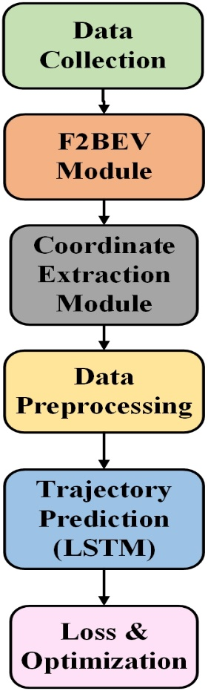
Fig. ‎4-1: Proposed Workflow for Ego Vehicle Trajectory Prediction

F2BEV Module
The F2BEV (Fisheye to Bird's Eye View) module reprojects fisheye surround-view images into spatially valid top-down representations. It uses a semantic segmentation network that is trained to recognize lanes, road edges, and relevant static objects. Such reformation avoids fisheye distortion and guarantees geometric consistency in the BEV space. The segmentation result retains critical features needed for predicting trajectories and presents a structured spatial organization. This phase is essential to the provision of a correct environmental context for the downstream prediction model in a coherent and understandable coordinate system.

Coordinate Extraction Module
The Coordinate Extraction Module selects the ego vehicle out of the output of BEV segmentation and computes its bounding box centre coordinates (X, Y) per frame. A tracking mechanism guarantees temporal consistency in coordinate labelling for sequences. These coordinates are stored systematically in a CSV file and constitute the structured dataset for model training. The module guarantees to minimize noise caused by segmentation errors using post-processing methods, delivering accurate and consistent positional information for trajectory modelling and prediction applications.

Trajectory Prediction Module (LSTM)
The Trajectory Prediction Module utilizes a Long Short-Term Memory (LSTM) network to capture temporal dependencies of vehicle motion. Previous sequence states of (X, Y) coordinates are used as inputs, enabling the network to learn patterns in motion and predict future locations within a specified time horizon. The LSTM structure is preferred due to its capability to maintain long-term dependencies with noisy inputs. This module facilitates advanced anticipatory decision-making in autonomous driving, enhancing collision avoidance, lane change aid, and navigation planning through prediction of probable vehicle motion.

Visualization Module
The Visualization Module superimposes forecast trajectories on BEV segmentation frames, creating a visible and understandable visual representation of model output. Color-coded paths for past and future locations are included, which allow for quick verification of prediction correctness. A composite trajectory video is also created, combining frame-by-frame overlays into an uninterrupted motion picture. Such a visual output not only assists with qualitative assessment but also assists with debugging, model improvement, and demonstration of system ability for autonomous driving system researchers, developers, and stakeholders.

Data Collection
The research utilizes the Volvo Cars FB-SSEM dataset [60], including high-resolution surround-view fisheye camera captures, supporting sensor metadata, and accurate synchronized timestamps. The data was captured under varied driving conditions, including urban roads, suburbs, and highways to mimic a broad set of real-world traffic scenarios. Weather variation, such as sunny, cloudy, rainy, and foggy weather conditions, and day and night light conditions are integrated to introduce model generalization. There are extensive ground truth annotations of vehicle position, lane markings, and scene context in the dataset, which allows for precise supervised learning and model testing. Sensor information involves sensor data from IMU, GPS, and vehicle control systems, which provides rich spatial and temporal insights to vehicle trajectories. The synchronized multimodal data guarantees visual and sensor measurement alignment for robust trajectory prediction. The extensive dataset provides a realistic platform for regression-based prediction model testing in autonomous driving scenarios, allowing adaptability in diverse environmental and operational situations.

Data Preprocessing

Spatial Preprocessing
Spatial preprocessing in the FB-SSEM dataset ensures consistency and accuracy of Bird's Eye View (BEV) maps before model training. All BEV maps are projected into a uniform coordinate reference frame for spatial coherence. Segmentation separates road elements, lanes, and nearby cars of interest. The centre of every detected object is calculated from bounding box coordinates as shown in Equation (4-1)
$X_{c}=\frac{x_{min}+x_{max}}{2}, Y_{c}=\frac{y_{min}+y_{max}}{2}$ (4-1)
Where, $x_{min}$ and $x_{max}$are the leftmost and rightmost x-coordinates of the bounding box, and $y_{min}$ , $y_{max}$ are the topmost and bottommost y-coordinates. Temporal ordering is maintained using a sliding window as shown in Equation (4-2)
$S_{t}→(X_{t+1},Y_{t+1})$ (4-2)
Where, $S_{t}$ is the spatial state at time $t$. Normalization eliminates scale variations, which allows all features to contribute equally to the regression-based trajectory prediction model necessary for accurate collision risk and lane-change analysis.

Object Extraction
Object extraction deals with the detection and segmentation of the ego vehicle inside Bird's Eye View (BEV) images in order to be used as the main reference for trajectory modeling. This process includes the identification of the vehicle's position and bounds inside the spatial map to allow accurate localization. By isolating the ego vehicle from other objects, spatial relations and motion patterns can be accurately analysed to ensure that future prediction models are trained with accurate and relevant data needed to perform strong and reliable trajectory forecasting in autonomous driving systems.

Feature Extraction
Feature extraction from Bird's Eye View (BEV) spatial preprocessing is the transformation of raw coordinate data into meaningful numerical values. The center position of the ego vehicle is computed by using bounding box limits for the x and y axes. Through this, the vehicle is accurately localized in the spatial map with positional context for trajectory prediction. Through pattern encoding of space and movement, preprocessing amplifies the model's capacity to understand nearby objects, predict routes, and enable trustworthy collision avoidance in autonomous navigation systems.

Temporal Sequence Preparation
In temporal sequence preparation for trajectory prediction, past spatial positions are converted into fixed-length sequences to accommodate the input needs of sequence models like LSTMs. All sequences retain $T$ consecutive position observations $(x_{t},y_{t})$so that the model is able to learn both temporal and spatial dependencies. The representation can be written as shown in Equation (4-3)
$S_{i}=\{\left(x_{t-T+1},y_{t-T+1}\right),…., (x_{t},y_{t})\}→(x_{t+1},y_{t+1})$ (4-3)
Here, $S_{i}$ refers to the formed sequence, $T$ is the window length, and$(x_{t+1},y_{t+1})$ is the target of prediction. The overlapping samples are ensured through the sliding window mechanism, maximizing data use and enhancing model generalization. The approach allows for effective capturing of movement patterns, variations in speed, and direction trends. Temporal structuring of this nature is an essential aspect of autonomous driving systems in terms of vehicle motion anticipation, collision avoidance, and smoother trajectory prediction.

Sequence Preparation for Trajectory Prediction
After preprocessing, the trajectory sequences generated are stored systematically to allow direct access during model training without needing redundant extraction steps. A stored record holds spatial coordinates, temporal indices, and related context features. This organized saving speeds up the experimental process and ensures data consistency. Organizing sequences in indexed formats optimizes retrieval for sequential models so that spatial–temporal patterns of importance for accurate trajectory prediction and efficient evaluation of regression-based prediction algorithms are not compromised.

Model Design
Trajectory forecasting, being inherently a sequence forecasting problem, can be formulated as a regression problem where the target outputs are the ego vehicle's future $(X,Y)$ coordinates. Framing the problem as regression allows the model to learn the continuous motion dynamics and spatial relationships of the vehicle over time. Such a method allows for precise forecasting of the next position of the vehicle using past trajectory information, speed, direction changes, and environmental factors present in Bird's Eye View (BEV) images. Regression-based modeling is also suitable for autonomous driving due to the fact that it yields detailed numeric results instead of categorical outputs, and thus allows continuous and smooth trajectory estimation. Moreover, casting trajectory prediction as regression makes it easier to integrate with downstream modules like collision avoidance, lane-change detection, and motion planning. Overall, this approach creates a solid foundation for sequence-based trajectory forecasting, taking advantage of temporal dependencies but making interpretable real-world coordinate predictions.

Rationale for LSTM in Trajectory Prediction
For predicting trajectories, a Long Short-Term Memory (LSTM) network is selected due to its special capability of dealing with sequential data. LSTMs can preserve long-term dependencies over time steps, which is very important in predicting vehicle trajectories from past position sequences. In contrast to the regular recurrent networks, LSTMs are specifically designed to avoid vanishing gradient problems so that they may learn complicated temporal patterns over long sequences. This ability renders them especially well-suited to represent non-linear motion patterns that are typical of actual driving conditions where the ego vehicle can accelerate, decelerate, or turn randomly. LSTMs also illustrate resistance to noisy measurements that are usually introduced by real-world sensor inputs like camera distortions or partial occlusions. The visual representation is shown in Fig. 4-2

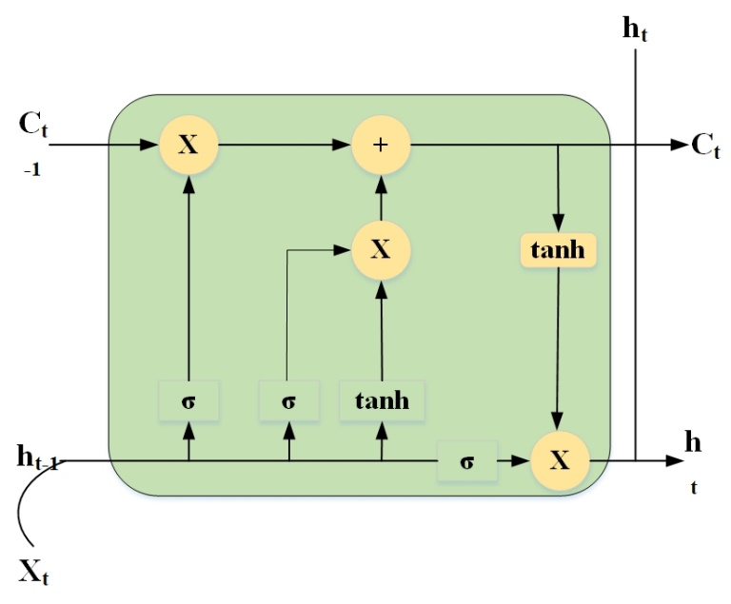
Fig. ‎4-2: LSTM Cell Structure for Ego Vehicle Trajectory Prediction

The LSTM cell computation can be expressed as Equation (4- 4), (4-5), (4-6), (4-7), (4-8) and (4-9)
$f_{t}=σ(W_{f}∙\left[h_{t-1},x_{t}\right]+b_{f})$ (4-4)
$i_{t}=σ(W_{i}∙\left[h_{t-1},x_{t}\right]+b_{i})$ (4-5)
$\overline{C_{t}}=tanh⁡(W_{c}∙\left[h_{t-1},x_{t}\right]+b_{c})$ (4-6)
$C_{t}=f_{t}⨀C_{t-1}+i_{i}⨀\overline{C_{t}}$ (4-7)
$o_{t}=σ(W_{o}∙\left[h_{t-1},x_{t}\right]+b_{o})$ (4-8)
$h_{t}=o_{t}⨀tanh⁡(C_{t})$ (4-9)
Here, $f_{t},i_{t},o_{t}$​ represent the forget, input, and output gates; $C_{t}$is the cell state; $h_{t}$​ is the hidden state; $x_{t}$is the input; and $W$ and $b$ are weights and biases. Their gating capabilities allow selective recall of significant temporal details while omitting inconsequential signals so that their predictions are accurate and stable. Therefore, LSTMs are the best-suited for regression-based trajectory prediction in autonomous vehicle contexts.

Model Architecture
- Input layer: The input layer of the LSTM regression model is designed to take sequences of 10 past coordinate pairs of the ego vehicle's historical positions. The sequence captures temporal development of the vehicle's movement so that the network can learn motion tendencies like deceleration, acceleration, turning, and lane change behaviour. By presenting the input as a sequence, the LSTM can more easily maintain long-term dependencies and temporal correlations among successive positions. The sequential representation also allows the network to separate relevant patterns from noise so that meaningful movements are highlighted during training. Well-prepared input sequences supply the model with context needed to accurately forecast the vehicle's future position. The input layer therefore provides an important basis for the network, allowing the LSTM to learn temporal features and facilitating accurate, smooth, and interpretable trajectory prediction for autonomous driving use cases.
- Hidden Layer: The hidden part of the regression model has two LSTM layers with 64 units each. These layers are used to detect complex temporal relationships and non-linear motion trends that exist in the ego vehicle's trajectory. Through their recursive structure, LSTM cells maintain significant long-term information from previous sequences while selectively discarding irrelevant or noisy information by means of gating mechanisms. This selective memory allows the network to concentrate on the significant motion trends, increasing the prediction stability and accuracy. Through the proper modelling of temporal correlations, the hidden layers are instrumental in creating dependable and smooth trajectory predictions in autonomous driving tasks.
- Dense Layer: After the LSTM layers, a dense fully connected layer is used to map the high-dimensional temporal features learned by the LSTM units onto a lower-dimensional output space in alignment with the target coordinates. The layer combines learned temporal relationships and motion patterns, aggregating information across all hidden units to output a coherent representation that is appropriate for regression. By making this mapping, the dense layer converts the abstract sequential features into actionable spatial predictions. It acts as a transition between the LSTM's temporal feature extraction and the output layer to guarantee that the trajectory prediction is accurate, smooth, and interpretable for autonomous driving.
- Output Layer: The LSTM-based regression model output layer produces the forecasted next position $\left(X_{t+1}, Y_{t+1}\right).$ The output layer offers continuous numerical outputs that indicate the vehicle's future spatial locations, making it suitable for smooth and accurate trajectory prediction. Through the conversion of processed temporal features from the dense layer to usable predictions, the output layer is the last step of the regression model. Precise predictions here are essential to autonomous driving missions, including path planning, collision avoidance, and motion control. The layer guarantees the output of the trajectory as being interpretable, trustworthy, and deployable in real time.

Loss and Optimization
The performance of the regression model based on LSTM is highly sensitive to the selection of loss function and the optimization process. In the trajectory prediction, the Mean Squared Error (MSE) loss function is utilized. MSE quantifies the average squared difference between the outputted coordinates $(X_{t+1},Y_{t+1})$ and ground truth labels. MSE discourages large deviations more by penalizing them more in order to make the model predict values close to the true vehicle path, making them more accurate and stable in continuous regression predictions.
In order to optimize the model parameters efficiently, the Adam optimizer is employed. Adam incorporates the best of Adaptive Gradient Algorithm (AdaGrad) and Root Mean Square Propagation (RMSProp) to provide adaptive learning rates for every parameter. It provides faster convergence and avoids the model from being trapped in local minima. The optimizer iteratively updates the weights by using gradient information from the loss function for efficient and stable training.
In combination, MSE loss and the Adam optimizer form a strong backbone for training the LSTM network to produce accurate, consistent, and smooth trajectory predictions that are reliable enough for use in real-time autonomous driving systems.

Conclusion
This chapter presented a detailed presentation of the proposed ego vehicle trajectory prediction system for autonomous driving. The system uses fisheye camera inputs to produce Bird's Eye View (BEV) representations, which provide precise spatial understanding of lanes, obstacles, and traffic context. The F2BEV module removes fisheye distortion and extracts significant environmental features, whereas the Coordinate Extraction Module calculates accurate ego vehicle positions as reference points for modelling trajectories. Long Short-Term Memory (LSTM) networks are utilized to learn temporal dependencies in vehicle motion so that precise future path prediction is enabled. The modular structure enables smooth combination of perception, localization, and prediction modules, while the Visualization Module offers interpretable results for debugging and verification. With the Volvo FB-SSEM dataset, extensive preprocessing—spatial alignment, object detection, feature embedding, and temporal sequence preparation—are enabled to support strong model training. The LSTM regression model trained with MSE loss and the Adam optimizer supports steady, continuous, and real-time trajectory prediction, improving collision avoidance, lane-change support, and motion planning.

Implementation

Overview
Implementation phase converts the architected design of the trajectory prediction framework into a working system. This chapter discusses the real-world implementation of the system, including dataset integration, BEV (Bird's Eye View) generation, preprocessing, and training of the LSTM-based regression model. Implementation also discusses the development environment, tools, and libraries used to integrate all the parts into a smooth workflow. The decisions taken in this stage correspond to system requirements like accuracy, robustness, and scalability. This phase transitions between the conceptual design and experimental verification of the framework.

Development Environment
The development environment is the basis to develop, test, and deploy the suggested trajectory prediction framework. It is made up of software frameworks, libraries, and hardware specifications that together allow the integration of data preprocessing from the dataset, BEV transformation, and training of deep learning models. The next table presents the environment setup:
Table ‎5-1: Implementation Setup for Ego Vehicle Trajectory Prediction.
Component | Description | Purpose/Role
Dataset | FB-SSEM Dataset (Volvo Cars) | Provides fisheye images, camera calibration, and metadata.
Programming Language | Python 3.7 | Core language for preprocessing, modeling, and visualization.
Deep Learning Frameworks | PyTorch& TensorFlow/Keras | PyTorch: BEV generation (F2BEV). TensorFlow/Keras: LSTM model training.
Computer Vision Tools | OpenCV | Used for fisheye correction, bounding box extraction, and BEV visualization.
Libraries | NumPy, Pandas, Matplotlib | Data handling, sequence preparation, and visualization.
Operating System | Ubuntu 22.04 (via WSL) | Development and execution environment.
IDE | VS Code | Coding, debugging, and modular integration.
Hardware | NVIDIA GPU-enabled system | Accelerates deep learning training.
This environment ensures compatibility, efficient debugging, and smooth execution across the modules.

Implementation of modules
The system is designed in modular fashion, which provides flexibility, scalability, and independent testing of modules prior to integration. Four primary modules are utilized: dataset preprocessing, BEV generation, LSTM trajectory prediction, and trajectory visualization.

Dataset Preprocessing Module
This module processes the FB-SSEM dataset, which includes fisheye images and calibration parameter. The images are fisheye corrected and transformed into BEV representation. Ego vehicle bounding boxes are localized in each frame, and their center coordinates $(X,Y)$ are obtained. These are saved in a structured CSV file, which is used as an input for sequence preparation.

BEV Generation Module
The F2BEV model, which is PyTorch implementation, maps fisheye camera inputs into top-down BEV segmentation maps. The maps annotate both dynamic objects (vehicles) and static objects (roads, lanes, obstacles). BEV offers a consistent spatial representation, important for trajectory prediction.

LSTM Prediction Module
This module prepares sequential data from the pre-processed coordinates in preparation. Every input has 10 previous coordinate pairs ($X_{t},Y_{t}$) whereas the output is a forecast of the next location $(X_{t+1},Y_{t+1})$. The LSTM structure has two layers of hidden state units of 64 each, followed by a dense layer that maps to forecast coordinates. The model is trained with Mean Squared Error (MSE) as the loss function and Adam optimizer for efficient gradient-based learning.

Trajectory Visualization Module
The predicted trajectory is traced as a red dotted line on the BEV maps, tracing over the true ego vehicle trajectory. OpenCV and Matplotlib are used to create a video of processed frames, presenting an evident representation of real-world trajectory prediction.

Demonstration Workflow
The process begins with preprocessing of the dataset, where fisheye images are converted into BEV maps and ego vehicle coordinates. These coordinates are organized into sequential data and fed into the LSTM model. While training, the model acquires temporal relationships and motion patterns. In the testing phase, the LSTM outputs future positions, which are displayed as trajectory overlays onto BEV frames. Lastly, the frames generated are stitched together into a video file, which creates a visual comparison of ground truth and predicted paths.

Conclusion
The deployment effectively converts the theoretical design into an operational trajectory prediction system. Through the incorporation of the FB-SSEM dataset, fisheye-to-BEV transformation, coordinate extraction, and LSTM-based regression modeling, the system reflects precise and interpretable predictions. The modular framework enables scalability, enabling future enhancement of elements individually, like the inclusion of attention mechanisms or multi-sensor fusion. This chapter lays the groundwork for experimental comparison and performance analysis in the subsequent phase of the research.

Result and Discussion

Overview
This chapter presents the evaluation of the suggested attention-based BEV segmentation and trajectory prediction architecture. The analysis commences with semantic segmenting of depth maps, where ground truth values are quantized into three semantic classes: Far, Mid, and Near. Quantitative measures, such as Intersection-over-Union (IoU), Mean IoU, and Pixel Accuracy, are presented to measure segmentation performance on these depth classes. A confusion matrix is also presented to show the class-level prediction strengths and weaknesses. Apart from segmentation, trajectory forecasting outcomes are shown in dynamic traffic scenes with Bird's Eye View (BEV) visualizations. The visualizations emphasize the system's strength in preserving spatial and temporal consistency when predicting the motion of the ego vehicle across different traffic situations. Collectively, the findings confirm the strength of the model in its ability to capture multi-view fisheye inputs, predict safe paths, and ensure consistent performance for autonomous driving use cases
Table ‎6-1: Depth Classes for Ground Truth Segmentation
Class | Description | Depth Range (Normalized)
0 | Far | ≥ 0.69
1 | Mild | 0.35 – 0.69
2 | Near | ≤ 0.35
Fig. 6-1 and Table 6.1 shows the ground truth depth map discretization into three semantic classes: Far, Mid, and Near. They are specified with normalized depth ranges, allowing the segmentation model to classify spatial information efficiently. The "Far" class is reserved for objects at farther distances, while the "Near" class indicates closer areas that are more susceptible to greater distortion and occlusion. The "Mid" class falls in the middle range and usually deals with transition boundaries between near and far objects. This category gives a well-structured framework for assessing segmentation accuracy and maintains consistency in understanding depth-based semantic information for BEV representation.
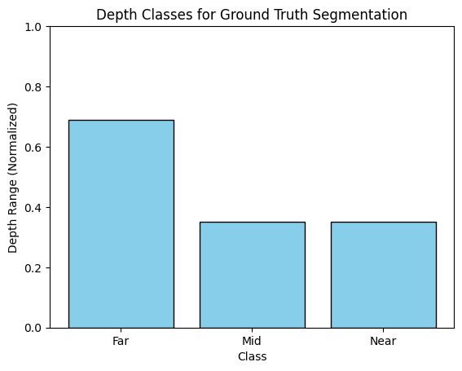
Fig. ‎6-1: Normalized Depth Ranges Categorized into Semantic Classes.

Table ‎6-2: Model Evaluation Metrics
Metric | Value
IoU (Class 0 – Far) | 0.76
IoU (Class 1 – Mid) | 0.61
IoU (Class 2 – Near) | 0.59
Mean IoU (mIoU) | 0.653
Pixel Accuracy | 84.7%
Fig. 6-2 and Table 6.2 provides a summary of the semantic BEV segmentation model's evaluation metrics. The Intersection-over-Union (IoU) measurements reveal strong performance on the Far class (0.76), whereas moderate lower results for Mid (0.61) and Near (0.59) reflect difficulty due to occlusion and lens distortion at nearer distances. The average IoU of 0.653 indicates well-balanced performance in segmentation among all classes, and the total Pixel Accuracy of 84.7% further ensures that attention-augmented BEV model makes good-quality predictions. All these results support the superiority of the model in extracting multi-view fisheye spatial features while achieving temporal consistency in frames.
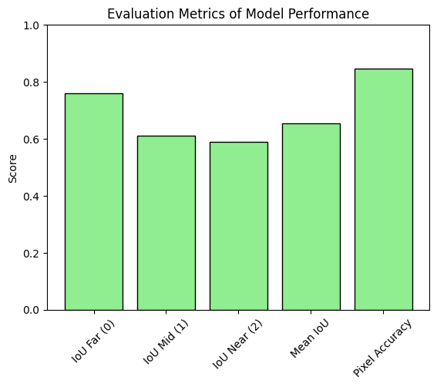
Fig. ‎6-2: Segmentation Model Evaluation Across Depth Ranges.

Table ‎6-3: Confusion Matrix of Predicted vs. Ground Truth Segmentation
 | Pred: Far (0) | Pred: Mild (1) | Pred: Near (2)
GT: Far (0) | 4321 | 289 | 72
GT: Mid (1) | 194 | 3812 | 219
GT: Near (2) | 61 | 253 | 3290
Fig. 6-3 and Table 6.3 depicts the confusion matrix between predicted and ground truth segmentation classes. Most "Far" pixels were successfully predicted (4321), affirming model dependability at larger distances. Misclassifications are more significant in Mid and Near classes, with some boundary overlap between categories. For example, 289 Mid pixels were unpredicted as Far, and 219 Mid pixels were predicted as Near, demonstrating difficulty in separating middle spatial areas. Despite these mistakes, the matrix identifies strong diagonal dominance, which points to firm overall performance. This evaluation validates the effectiveness of the model while pointing out areas where boundary refinement would make accuracy even better.
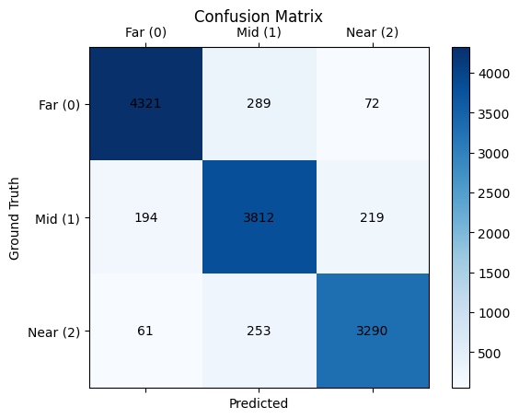
Fig. ‎6-3: Confusion Matrix.

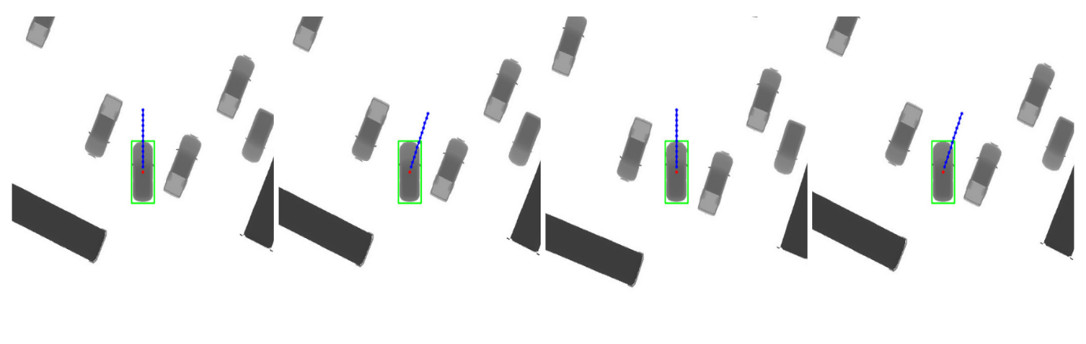
Fig. ‎6-4: Ego Vehicle Trajectory Prediction.

Fig. 6-4 shows the ego vehicle's trajectory prediction result in an environment of dynamic traffic. The ego vehicle, which is shown with a green bounding box, moves through various surrounding obstacles and vehicles. The predicted trajectory is displayed as blue dashed lines, and the ground-truth path is displayed with red markers. Left to right, the sequential frames show the model's capacity for real-time adjustments of its trajectory predictions as the vehicle continues along its route. The predicted trajectories continue to align with the ground truth, reflecting good performance by the model in forecasting future positions under diverse traffic conditions. Visualization also shows how the system ensures safe navigation without risking collisions with neighboring cars and static obstacles. These findings confirm the efficacy of the suggested trajectory forecasting framework in providing dependable motion forecasting, which is vital for decision-making in autonomous vehicles and advanced driver-assistance systems (ADAS).
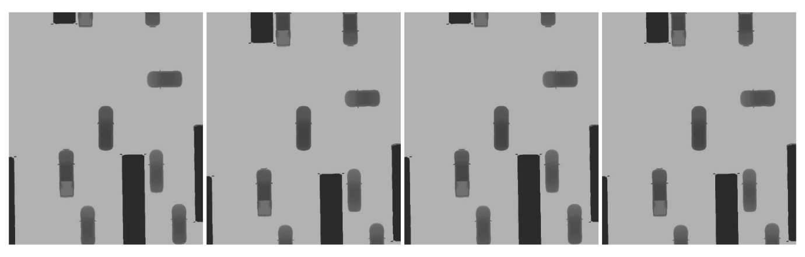
Fig. ‎6-5: BEV segmentation of vehicles and obstacles.

Fig. shows a series of Bird's Eye View (BEV) depth-based visualizations of a traffic scene, with both dynamic vehicles and static obstacles. Grayscale encoding represents depth, where dark areas indicate nearer objects and lighter areas indicate further distances. Through the subsequent frames, several vehicles, such as cars and bigger trucks, are seen moving on organized lanes, whereas nearby static obstacles remain stable. The object displacement variation from frame to frame reflects the dynamic environment and also pinpoints the model's temporal consistency in depth estimation. The correct distinction of near, mid, and far areas ensures stable perception of the surroundings of vehicles, and this is important for safe navigation and collision prevention. This visualization illustrates that this system enables effective representation of depth-aware spatial structures, hence making it viable for trajectory forecasting, motion planning, and decision-making processes under autonomous driving applications.
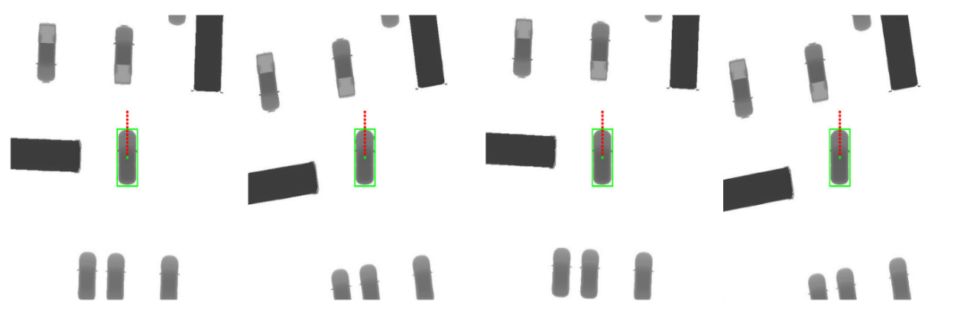
Fig. ‎6-6: BEV-Based Trajectory Forecasting.

Fig. 6-6 depicts a series of Bird's Eye View (BEV) frames demonstrating ego vehicle trajectory prediction within an organized traffic scene. The ego vehicle is outlined in green, with the predicted future trajectory appearing as a set of red dotted points propagating ahead. The dotted lines demonstrate the LSTM-based prediction of the vehicle motion from the previous positional coordinates. The surrounding objects, such as other vehicles and big stationary obstacles, are represented in grayscale, where darker color tones correspond to closer objects and lighter color tones to distant ones. Through the sequence, the predicted path has consistency with the expected motion of the vehicle forward, exhibiting accuracy and temporal consistency in path forecasting. The visualization successfully depicts how the system forecasts the path of the ego vehicle, considering surrounding traffic participants and stationary obstacles. These outcomes affirm the effectiveness of the system towards autonomous driving applications, specifically in motion planning and collision avoidance.

Discussion
The results from this study emphasize the promise of integrating fisheye surround-view cameras, Bird's Eye View (BEV) transformation, and Long Short-Term Memory (LSTM) networks for cost-effective and accurate trajectory prediction in autonomous driving systems. As opposed to LiDAR and radar, which are highly accurate but are limited by cost and integration, fisheye cameras offer a low-cost solution with a large field of view. Yet, their geometric deformations need to be corrected for accurate trajectory estimation. BEV transformation solves this problem effectively by producing distortion-free, spatially coherent representations that facilitate robust road feature detection and vehicle localization.
The inclusion of LSTM models also enhances the framework by tapping into temporal dependencies across sequential motion data. This is more reliable for regression-based prediction of continuous (X, Y) coordinates that are actionable for low-level vehicle control mechanisms. While classification-based prediction techniques are generally more straightforward, regression is more precise and flexible, especially in dynamic urban scenarios where smooth responses are essential.
The literature review showed a gap in regression-based BEV prediction models based on fisheye data, and most previous works were limited to classification or semantic segmentation. By filling this gap, the proposed model exhibits a scalable solution with the potential to improve real-time decision-making in autonomous cars. However, difficulties still exist in generalization across a wide range of environmental settings, optimization for embedded systems, and robustness against uncommon occurrences or sensor failures.
In total, this research highlights the significance of vision-based regression models underpinned by BEV transformation in the provision of precise, cost-effective, and real-time trajectory prediction, consequently promoting safer and more efficient autonomous driving technologies

Conclusion and Future Work

Overview
This chapter provides the concluding remarks of the research and highlights possible avenues for future improvement. The chapter commences with an overview of the contributions and findings of the project, followed by an analysis of the limitations that arose during the research. Last, the chapter presents future research directions as well as potential improvements that can be made to enhance the proposed ego vehicle trajectory prediction framework in terms of reliability, efficiency, and scalability.

Conclusion
The study set out to design and deploy an end-to-end regression-based system to forecast the future path of an ego vehicle from surround-view fisheye cameras, Bird's Eye View (BEV) projection, and Long Short-Term Memory (LSTM) networks. This was driven by the necessity to lower reliance on costly and computational power-hungry sensor devices like LiDAR and radar while maintaining accurate and reliable trajectory prediction for autonomous vehicles.
The main contribution of this research is the combination of fisheye-based perception with BEV transformation to address geometric distortions in wide-angle images. Through fisheye input transformation into spatially aligned BEV maps, the system promoted correct object localization and offered a consistent geometric frame for trajectory forecasting. The derivation of ego vehicle center coordinates from BEV formats facilitated preparation of structured time-series datasets amenable to regression modeling.
The regression model based on LSTM was successful in capturing temporal dependencies in motion sequences to provide continuous (X, Y) predictions of the future positions of the vehicle. In contrast to classification-based models that depend on discrete categories of maneuvers, this approach enabled fine-grained estimation of the trajectory that could be directly actionable for low-level control in autonomous driving systems. Performance assessment based on Mean Squared Error (MSE) and Mean Absolute Error (MAE) showed the effectiveness of the proposed pipeline in smooth and interpretable trajectory prediction.
Additionally, the results affirm that camera-based regression models, aided by BEV transformation and LSTM modeling, can offer a cost-effective and efficient substitute for conventional sensor-intensive systems. This work thus supports the continued expansion of scalable, real-time, and low-cost alternatives for autonomous vehicle trajectory prediction.

Limitation
While the proposed framework showed promising performance, there are numerous limitations. The Volvo FB-SSEM dataset did not have variations in weather, lighting, and traffic, limiting the model from generalizing across different environments. The use of fisheye cameras brings in glare sensitivity, occlusions, and low light sensitivity, which can compromise real-world performance. LSTM models, though proficient in temporal learning, are computationally expensive and can pose difficulties in real-time execution on embedded systems. In addition, the framework does not model explicitly interactions with other agents and thus confines robustness for complicated urban traffic. Uncommon and unforeseen events, like unexpected pedestrian crossings, are also hard to manage.

Future work
Future work can focus various directions to improve the scalability and robustness of the proposed method. One such direction is data diversification and expansion to cover more diverse environmental conditions, e.g., rural roads, extreme weather, and heavy urban traffic, and leveraging synthetic data generation or transfer learning techniques to overcome the paucity of fisheye-based datasets. Another direction is sensor fusion techniques to integrate, with the complementary inputs from radar or low-res LiDAR being augmented by fisheye cameras to enhance prediction accuracy in adverse weather. To facilitate real-time deployment, model optimization strategies like pruning, quantization, or substituting LSTM networks with lightweight options like GRUs or Transformers should be investigated. In addition, the use of interaction-aware models that are able to account for surrounding vehicles' and pedestrians' dynamic behavior will improve the robustness of the system in highly complicated traffic scenarios. Probabilistic prediction and uncertainty quantification can similarly be incorporated to cope with rare or unforeseen events in a better manner, thus improving safety in critical situations. Moreover, verification of the framework on actual autonomous driving platforms will be critical to measure latency, reliability, and scalability in real-world scenarios beyond engineered datasets. Lastly, adaptive and online learning methods can be integrated to enable the system to evolve with new driving scenarios and behaviors continuously, providing long-term adaptability. Altogether, these directions are promising avenues to improve the efficacy and practicality of fisheye-BEV-based regression models for trajectory prediction in autonomous vehicles.

References
[1] L. K. Sahoo and V. Varadarajan, “Deep learning for autonomous driving systems: technological innovations, strategic implementations, and business implications-a comprehensive review,” Complex Eng. Syst., vol. 5, no. 1, p. N-A, 2025.
[2] D. Garikapati and S. S. Shetiya, “Autonomous vehicles: Evolution of artificial intelligence and the current industry landscape,” Big Data Cogn. Comput., vol. 8, no. 4, p. 42, 2024.
[3] F. Leon and M. Gavrilescu, “A review of tracking and trajectory prediction methods for autonomous driving,” Mathematics, vol. 9, no. 6, p. 660, 2021.
[4] W. Xu, R. Sainct, D. Gruyer, and O. Orfila, “Safe vehicle trajectory planning in an autonomous decision support framework for emergency situations,” Appl. Sci., vol. 11, no. 14, p. 6373, 2021.
[5] N. A. Madjid et al., “Trajectory prediction for autonomous driving: Progress, limitations, and future directions,” ArXiv Prepr. ArXiv250303262, 2025.
[6] L. Wang et al., “Multi-modal and multi-scale fusion 3D object detection of 4D radar and LiDAR for autonomous driving,” IEEE Trans. Veh. Technol., vol. 72, no. 5, pp. 5628–5641, 2022.
[7] V. R. Kumar, C. Eising, C. Witt, and S. K. Yogamani, “Surround-view fisheye camera perception for automated driving: Overview, survey & challenges,” IEEE Trans. Intell. Transp. Syst., vol. 24, no. 4, pp. 3638–3659, 2023.
[8] C. Eising, J. Horgan, and S. Yogamani, “Near-field perception for low-speed vehicle automation using surround-view fisheye cameras,” IEEE Trans. Intell. Transp. Syst., vol. 23, no. 9, pp. 13976–13993, 2021.
[9] D. Jakab et al., “Surround-view fisheye optics in computer vision and simulation: Survey and challenges,” IEEE Trans. Intell. Transp. Syst., vol. 25, no. 9, pp. 10542–10563, 2024.
[10] Z. Lin, Y. Wang, S. Qi, N. Dong, and M.-H. Yang, “Bev-mae: Bird’s eye view masked autoencoders for point cloud pre-training in autonomous driving scenarios,” in Proceedings of the AAAI conference on artificial intelligence, 2024, pp. 3531–3539.
[11] M. Sun, “Multi-sensor data fusion and management strategies for robust perception in autonomous vehicles,” Nuvern Appl. Sci. Rev., vol. 8, no. 10, pp. 59–68, 2024.
[12] M. Nawaz, J. K.-T. Tang, K. Bibi, S. Xiao, H.-P. Ho, and W. Yuan, “Robust cognitive capability in autonomous driving using sensor fusion techniques: A survey,” IEEE Trans. Intell. Transp. Syst., vol. 25, no. 5, pp. 3228–3243, 2023.
[13] R. Song and B. Li, “Surrounding vehicles’ lane change maneuver prediction and detection for intelligent vehicles: A comprehensive review,” IEEE Trans. Intell. Transp. Syst., vol. 23, no. 7, pp. 6046–6062, 2021.
[14] P. K. Dhindsa, “Studies on Next-Gen Vehicular Detection: A Fusion of RF Signal and Fisheye Camera Technologies,” PhD Thesis, Waseda University, 2024.
[15] A. Das et al., “Fisheye camera and ultrasonic sensor fusion for near-field obstacle perception in bird’s-eye-view,” ArXiv Prepr. ArXiv240200637, 2024.
[16] M. I. Pavel, S. Y. Tan, and A. Abdullah, “Vision-based autonomous vehicle systems based on deep learning: A systematic literature review,” Appl. Sci., vol. 12, no. 14, p. 6831, 2022.
[17] F. Deufel, P. Jhaveri, M. Harter, M. Gießler, and F. Gauterin, “Velocity prediction based on map data for optimal control of electrified vehicles using recurrent neural networks (lstm),” Vehicles, vol. 4, no. 3, pp. 808–824, 2022.
[18] S. Sitthiracha, C. Nantabut, S. Koetniyom, and G. Phanomchoeng, “Human-like trajectory planning for autonomous vehicles using flexible virtual reference points in car overtaking motorcycle scenarios,” Eng. J., vol. 28, no. 10, pp. 77–91, 2024.
[19] M. Gulzar, Y. Muhammad, and N. Muhammad, “A survey on motion prediction of pedestrians and vehicles for autonomous driving,” IEEE Access, vol. 9, pp. 137957–137969, 2021.
[20] F. Khosravikia and P. Clayton, “Machine learning in ground motion prediction,” Comput. Geosci., vol. 148, p. 104700, 2021.
[21] Y. Yoon, “Prediction-based Motion Planning for Autonomous Driving in Dynamic Traffic Environment,” PhD Thesis, 서울대학교 대학원, 2024.
[22] Z. Zhu et al., “Understanding the robustness of 3D object detection with bird’s-eye-view representations in autonomous driving,” in Proceedings of the IEEE/CVF Conference on Computer Vision and Pattern Recognition, 2023, pp. 21600–21610.
[23] Y. Zhang et al., “Beverse: Unified perception and prediction in birds-eye-view for vision-centric autonomous driving,” ArXiv Prepr. ArXiv220509743, 2022.
[24] R. Korbmacher and A. Tordeux, “Review of pedestrian trajectory prediction methods: Comparing deep learning and knowledge-based approaches,” IEEE Trans. Intell. Transp. Syst., vol. 23, no. 12, pp. 24126–24144, 2022.
[25] B. I. Sighencea, R. I. Stanciu, and C. D. Căleanu, “A review of deep learning-based methods for pedestrian trajectory prediction,” Sensors, vol. 21, no. 22, p. 7543, 2021.
[26] H. Yu, S. Huo, M. Zhu, Y. Gong, and Y. Xiang, “Machine learning-based vehicle intention trajectory recognition and prediction for autonomous driving,” ArXiv Prepr. ArXiv240216036, 2024.
[27] D. Choi, J. Yim, M. Baek, and S. Lee, “Machine learning-based vehicle trajectory prediction using v2v communications and on-board sensors,” Electronics, vol. 10, no. 4, p. 420, 2021.
[28] Q. Zhang, S. Hu, J. Sun, Q. A. Chen, and Z. M. Mao, “On adversarial robustness of trajectory prediction for autonomous vehicles,” in Proceedings of the IEEE/CVF Conference on Computer Vision and Pattern Recognition, 2022, pp. 15159–15168.
[29] V. Bharilya and N. Kumar, “Machine learning for autonomous vehicle’s trajectory prediction: A comprehensive survey, challenges, and future research directions,” Veh. Commun., vol. 46, p. 100733, 2024.
[30] S. Capobianco, L. M. Millefiori, N. Forti, P. Braca, and P. Willett, “Deep learning methods for vessel trajectory prediction based on recurrent neural networks,” IEEE Trans. Aerosp. Electron. Syst., vol. 57, no. 6, pp. 4329–4346, 2021.
[31] J. Liang, C. Tan, L. Yan, J. Zhou, G. Yin, and K. Yang, “Interaction-aware trajectory prediction for safe motion planning in autonomous driving: A transformer-transfer learning approach,” IEEE Trans. Intell. Transp. Syst., 2025.
[32] R. Chai, D. Liu, T. Liu, A. Tsourdos, Y. Xia, and S. Chai, “Deep learning-based trajectory planning and control for autonomous ground vehicle parking maneuver,” IEEE Trans. Autom. Sci. Eng., vol. 20, no. 3, pp. 1633–1647, 2022.
[33] H. Song, D. Luan, W. Ding, M. Y. Wang, and Q. Chen, “Learning to predict vehicle trajectories with model-based planning,” in Conference on Robot Learning, PMLR, 2022, pp. 1035–1045.
[34] M. Golchoubian, M. Ghafurian, K. Dautenhahn, and N. L. Azad, “Pedestrian trajectory prediction in pedestrian-vehicle mixed environments: A systematic review,” IEEE Trans. Intell. Transp. Syst., vol. 24, no. 11, pp. 11544–11567, 2023.
[35] N. A. Madjid et al., “Trajectory prediction for autonomous driving: Progress, limitations, and future directions,” ArXiv Prepr. ArXiv250303262, 2025.
[36] F. Leon and M. Gavrilescu, “A review of tracking and trajectory prediction methods for autonomous driving,” Mathematics, vol. 9, no. 6, p. 660, 2021.
[37] S. Yao et al., “Radar-camera fusion for object detection and semantic segmentation in autonomous driving: A comprehensive review,” IEEE Trans. Intell. Veh., vol. 9, no. 1, pp. 2094–2128, 2023.
[38] P. Ghorai, A. Eskandarian, Y.-K. Kim, and G. Mehr, “State estimation and motion prediction of vehicles and vulnerable road users for cooperative autonomous driving: A survey,” IEEE Trans. Intell. Transp. Syst., vol. 23, no. 10, pp. 16983–17002, 2022.
[39] K. Shi et al., “Radar and camera fusion for object detection and tracking: a comprehensive survey,” ArXiv Prepr. ArXiv241019872, 2024.
[40] S. Baek, J. Kim, and K. Yi, “Robust tracking and detection based on radar camera fusion filtering in urban autonomous driving,” Intell. Serv. Robot., vol. 17, no. 6, pp. 1125–1141, 2024.
[41] S. Li and H.-S. Yoon, “Sensor fusion-based vehicle detection and tracking using a single camera and radar at a traffic intersection,” Sensors, vol. 23, no. 10, p. 4888, 2023.
[42] F. Guan, H. Xu, and Y. Tian, “Evaluation of roadside LiDAR-based and vision-based multi-model all-traffic trajectory data,” Sensors, vol. 23, no. 12, p. 5377, 2023.
[43] B. Yang, J. Li, and T. Zeng, “A review of environmental perception technology based on multi-sensor information fusion in autonomous driving,” World Electr. Veh. J., vol. 16, no. 1, p. 20, 2025.
[44] D. Unger, N. Gosala, V. R. Kumar, S. Borse, A. Valada, and S. Yogamani, “Multi-camera Bird’s Eye View Perception for Autonomous Driving,” in Computer Vision, Chapman and Hall/CRC, 2024, pp. 279–295.
[45] Y. Zhang et al., “Beverse: Unified perception and prediction in birds-eye-view for vision-centric autonomous driving,” ArXiv Prepr. ArXiv220509743, 2022.
[46] Z. Yu, J. Li, Y. Wei, Y. Lyu, and X. Tan, “Combining Camera–LiDAR Fusion and Motion Planning Using Bird’s-Eye View Representation for End-to-End Autonomous Driving,” Drones, vol. 9, no. 4, p. 281, 2025.
[47] D. A. Oladele, E. D. Markus, and A. M. Abu-Mahfouz, “Bev-cam3d: A unified bird’s-eye view architecture for autonomous driving with monocular cameras and 3d point clouds,” AI, vol. 6, no. 4, p. 82, 2025.
[48] H. Rashed, M. Essam, M. Mohamed, A. E. Sallab, and S. Yogamani, “Bev-modnet: Monocular camera based bird’s eye view moving object detection for autonomous driving,” in 2021 IEEE International Intelligent Transportation Systems Conference (ITSC), IEEE, 2021, pp. 1503–1508.
[49] A. Loukkal, Y. Grandvalet, T. Drummond, and Y. Li, “Driving among flatmobiles: Bird-eye-view occupancy grids from a monocular camera for holistic trajectory planning,” in Proceedings of the IEEE/CVF Winter Conference on Applications of Computer Vision, 2021, pp. 51–60.
[50] S. Xie et al., “Benchmarking and improving bird’s eye view perception robustness in autonomous driving,” IEEE Trans. Pattern Anal. Mach. Intell., 2025.
[51] W. Liao et al., “CalibRBEV: Multi-Camera Calibration via Reversed Bird’s-eye-view Representations for Autonomous Driving,” in Proceedings of the 32nd ACM International Conference on Multimedia, 2024, pp. 9145–9154.
[52] A. Hu et al., “Fiery: Future instance prediction in bird’s-eye view from surround monocular cameras,” in Proceedings of the IEEE/CVF International Conference on Computer Vision, 2021, pp. 15273–15282.
[53] W. Jun and S. Lee, “A Comparative Study and Optimization of Camera-Based BEV Segmentation for Real-Time Autonomous Driving,” Sensors, vol. 25, no. 7, p. 2300, 2025.
[54] F. Leon and M. Gavrilescu, “A review of tracking and trajectory prediction methods for autonomous driving,” Mathematics, vol. 9, no. 6, p. 660, 2021.
[55] V. R. Kumar, C. Eising, C. Witt, and S. K. Yogamani, “Surround-view fisheye camera perception for automated driving: Overview, survey & challenges,” IEEE Trans. Intell. Transp. Syst., vol. 24, no. 4, pp. 3638–3659, 2023.
[56] Y. X. Li, “Efficient perception methods for autonomous driving via bird’s-eye-view representation,” PhD Thesis, Nanyang Technological University, 2025.
[57] Y. Ma et al., “Vision-centric bev perception: A survey,” IEEE Trans. Pattern Anal. Mach. Intell., 2024.
[58] Z. Yang et al., “Equivfisheye: A Spherical Fusion Framework for Panoramic 3d Perception with Surround-View Fisheye Cameras,” Available SSRN 5232063.
[59] F. Romanelli, “Multi-Sensor Fusion for Autonomous Resilient Perception”.
[60] volvo-cars, “GitHub - volvo-cars/FB-SSEM-dataset: The FB-SSEM dataset is a synthetic datasetconsisting of surround-view fisheye camera images and BEV maps from simulated sequences of ego car motion,” GitHub. Accessed: Aug. 14, 2025. [Online]. Available: https://github.com/volvo-cars/FB-SSEM-dataset

Appendix 1: Code listing
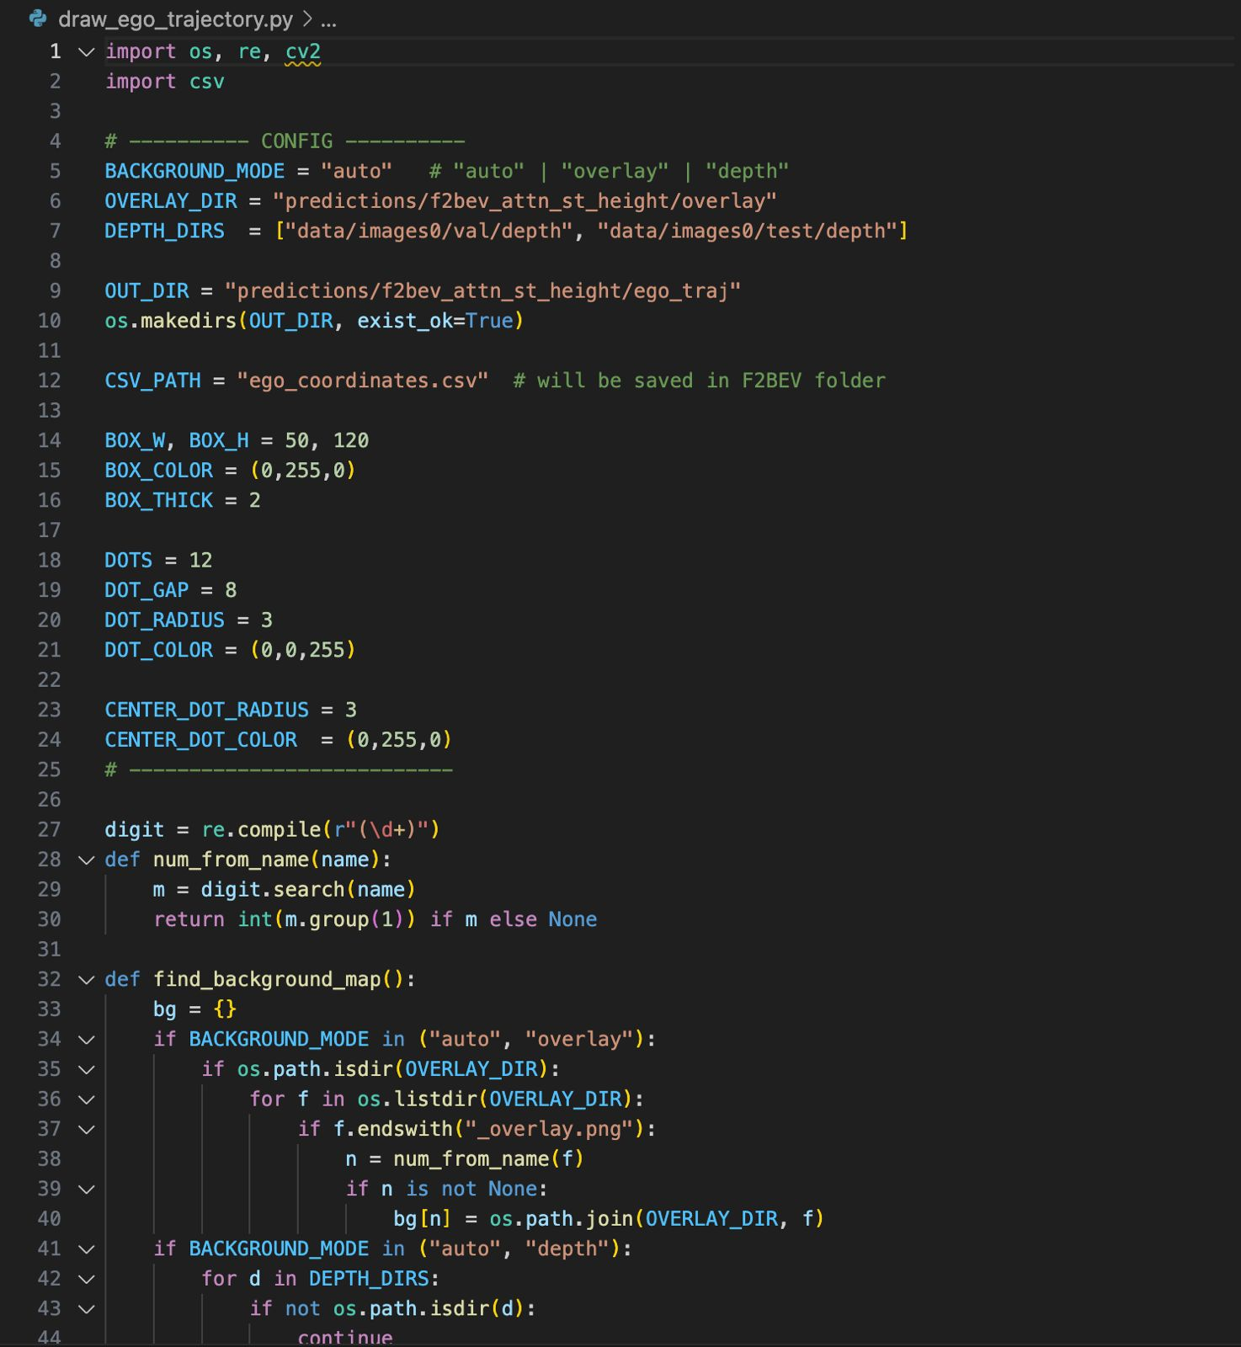

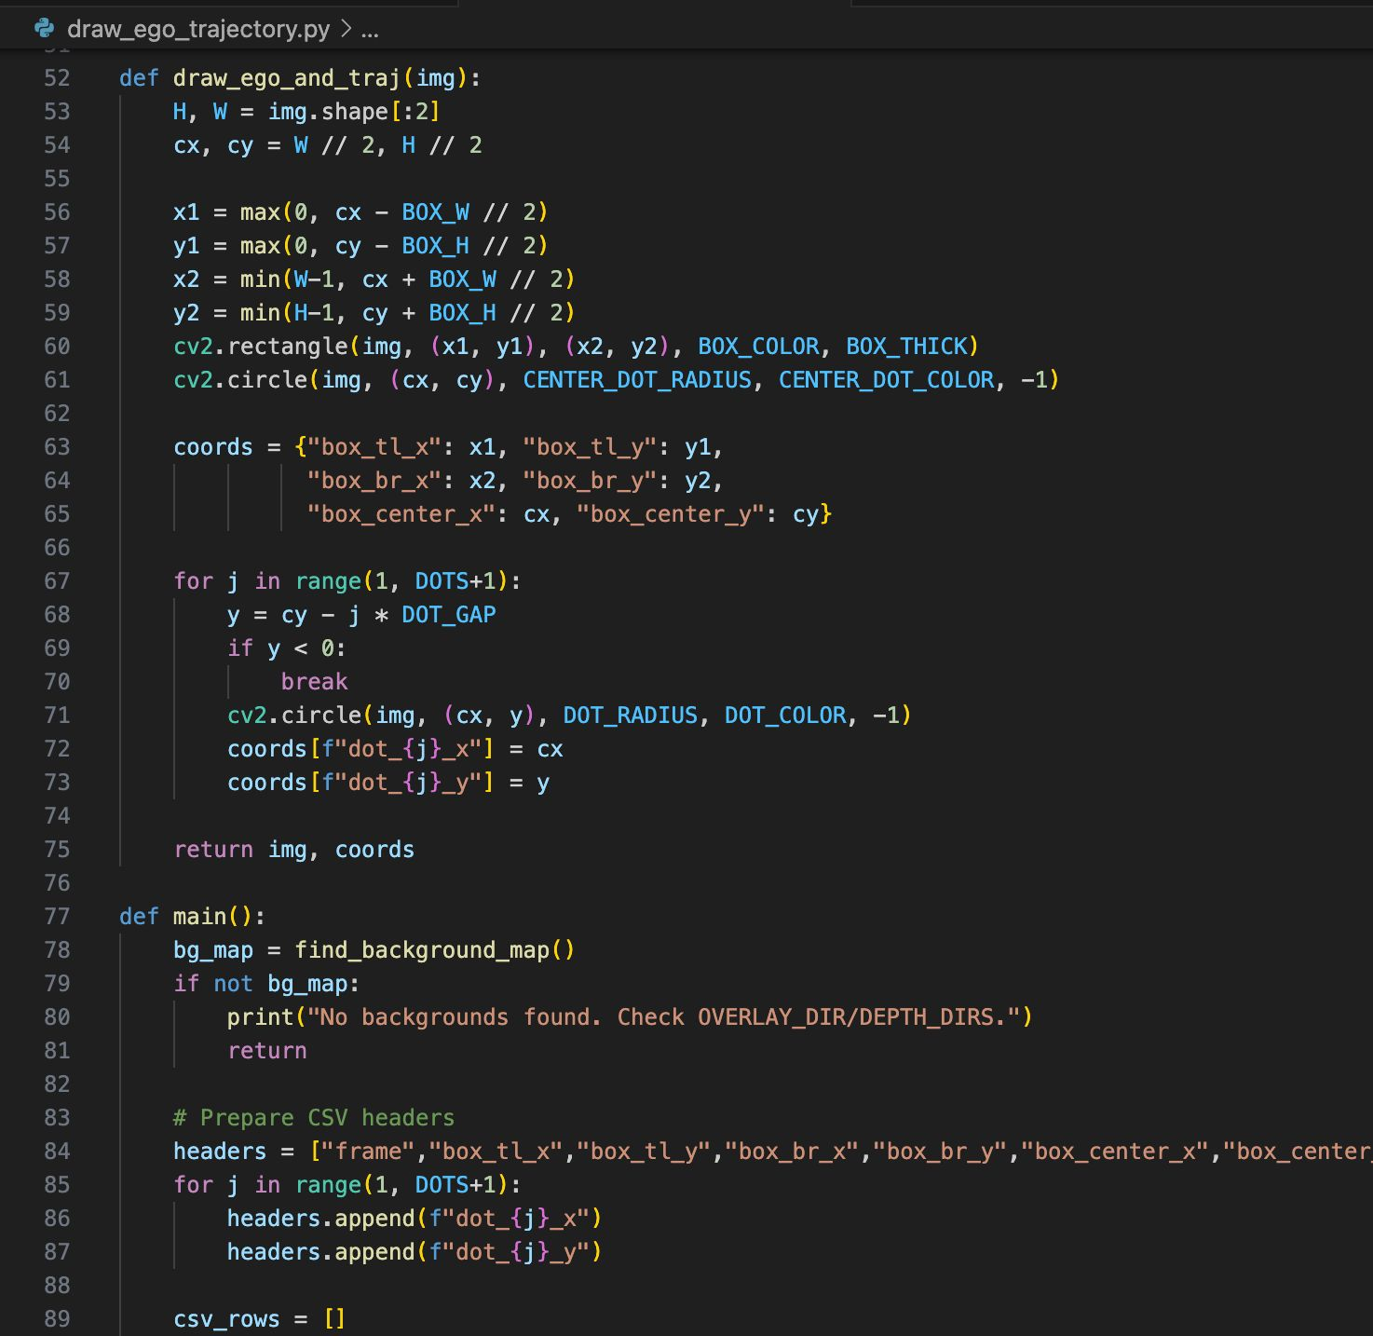

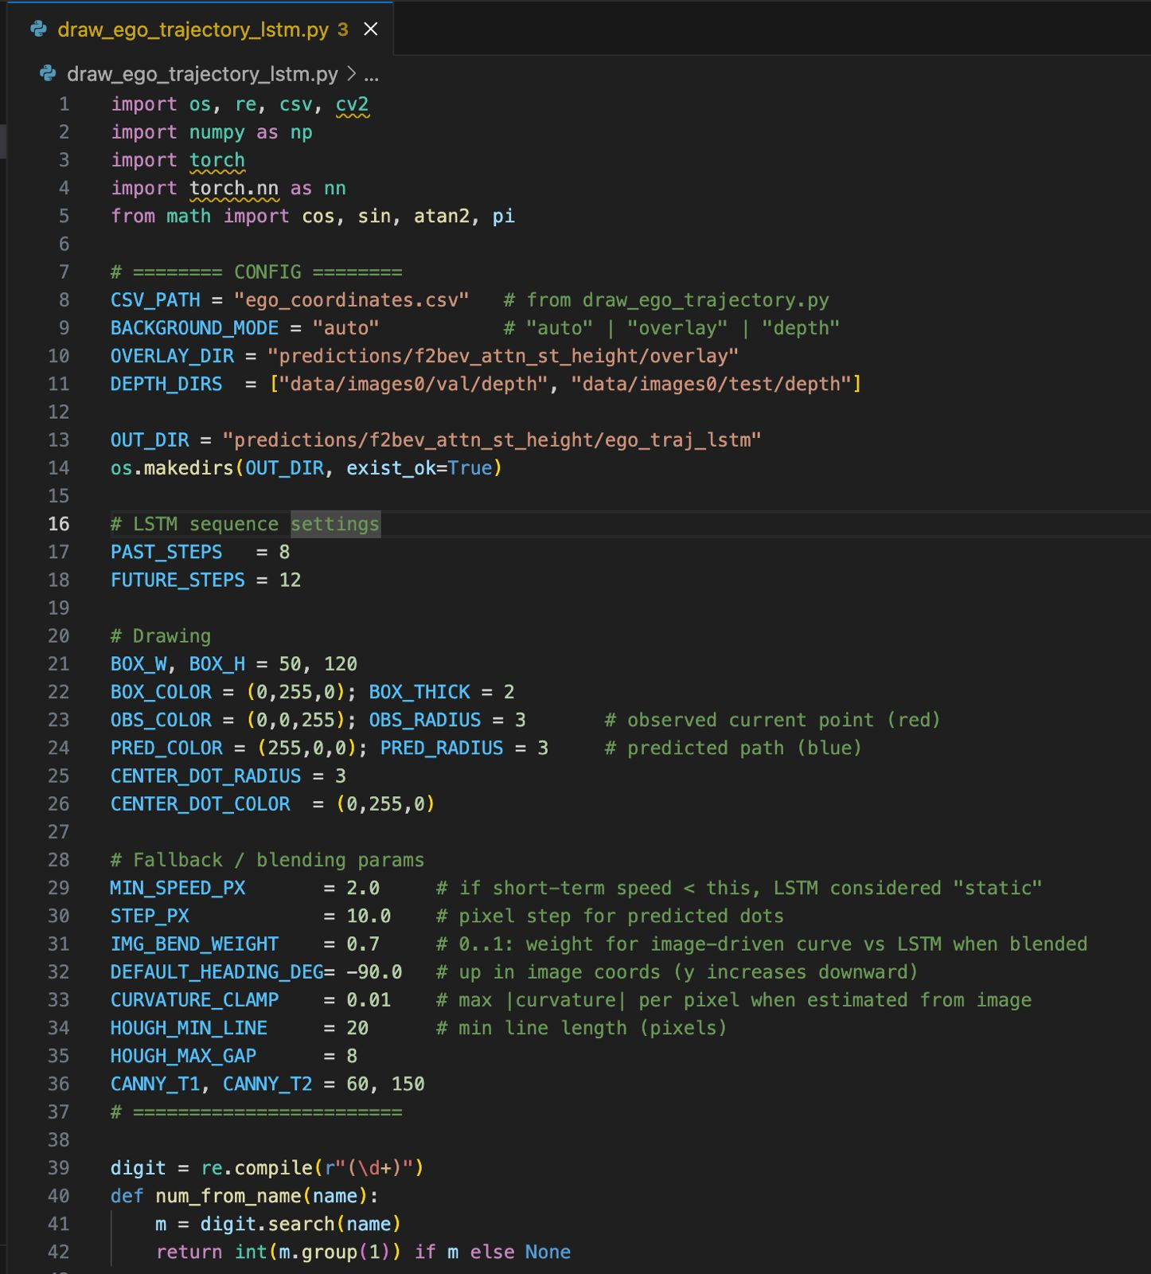

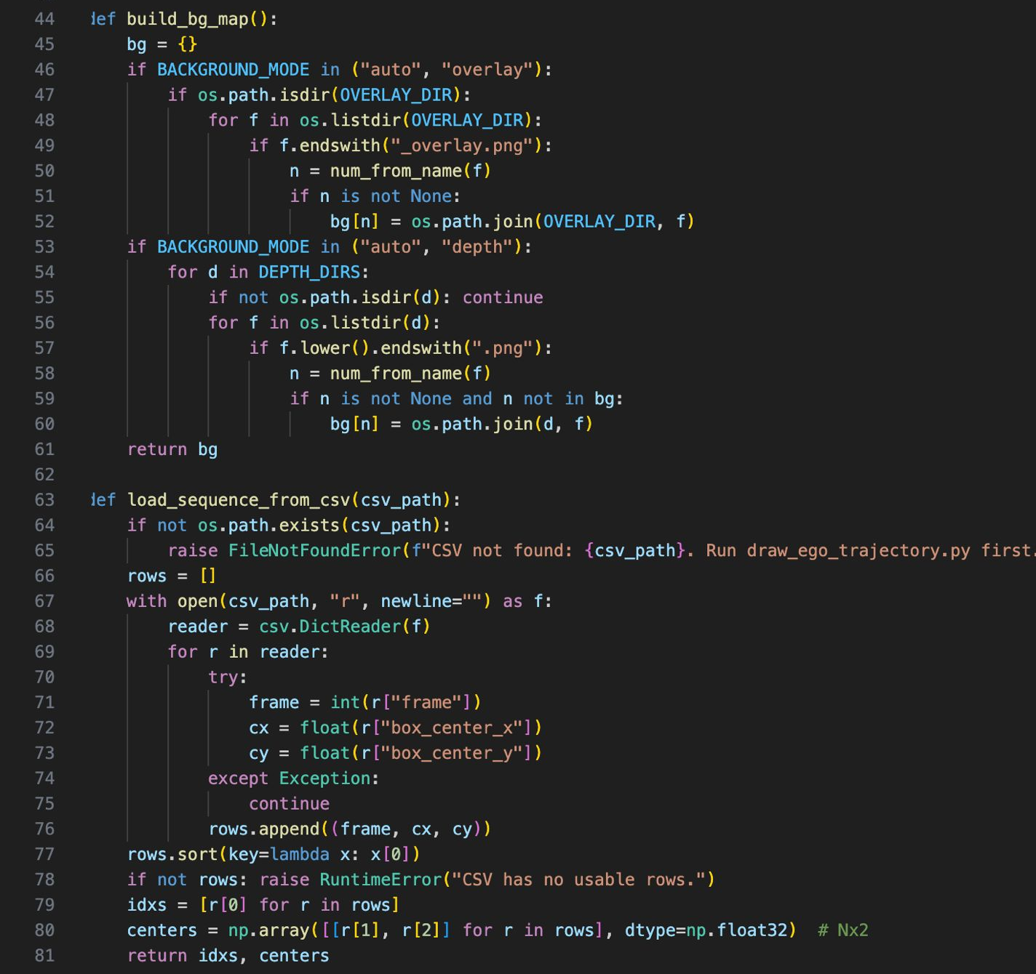

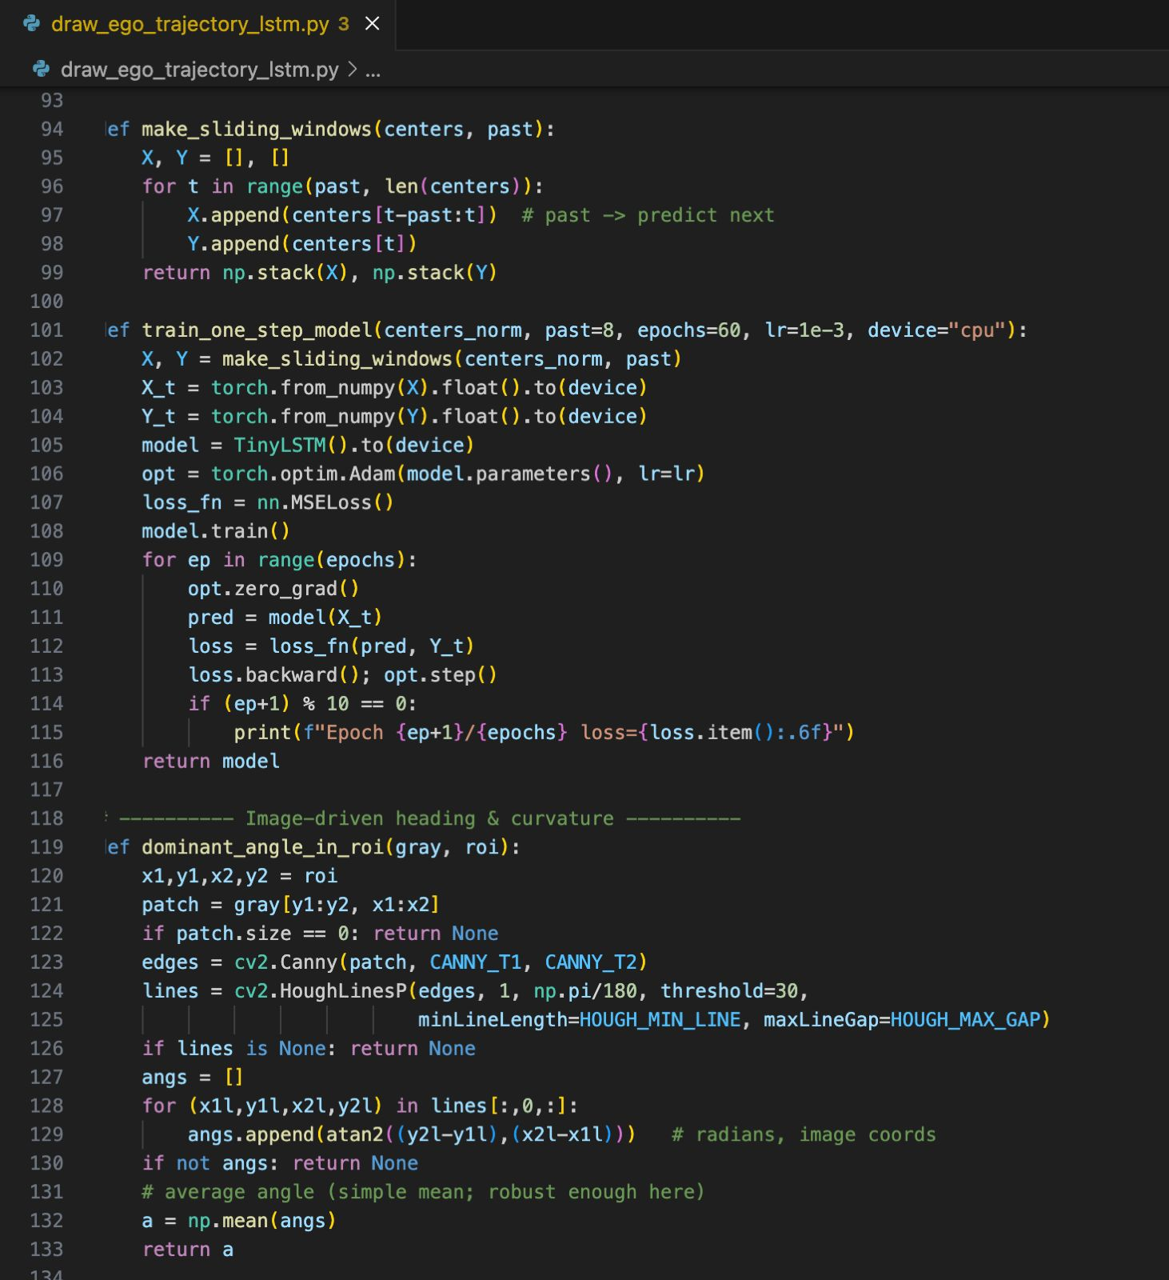

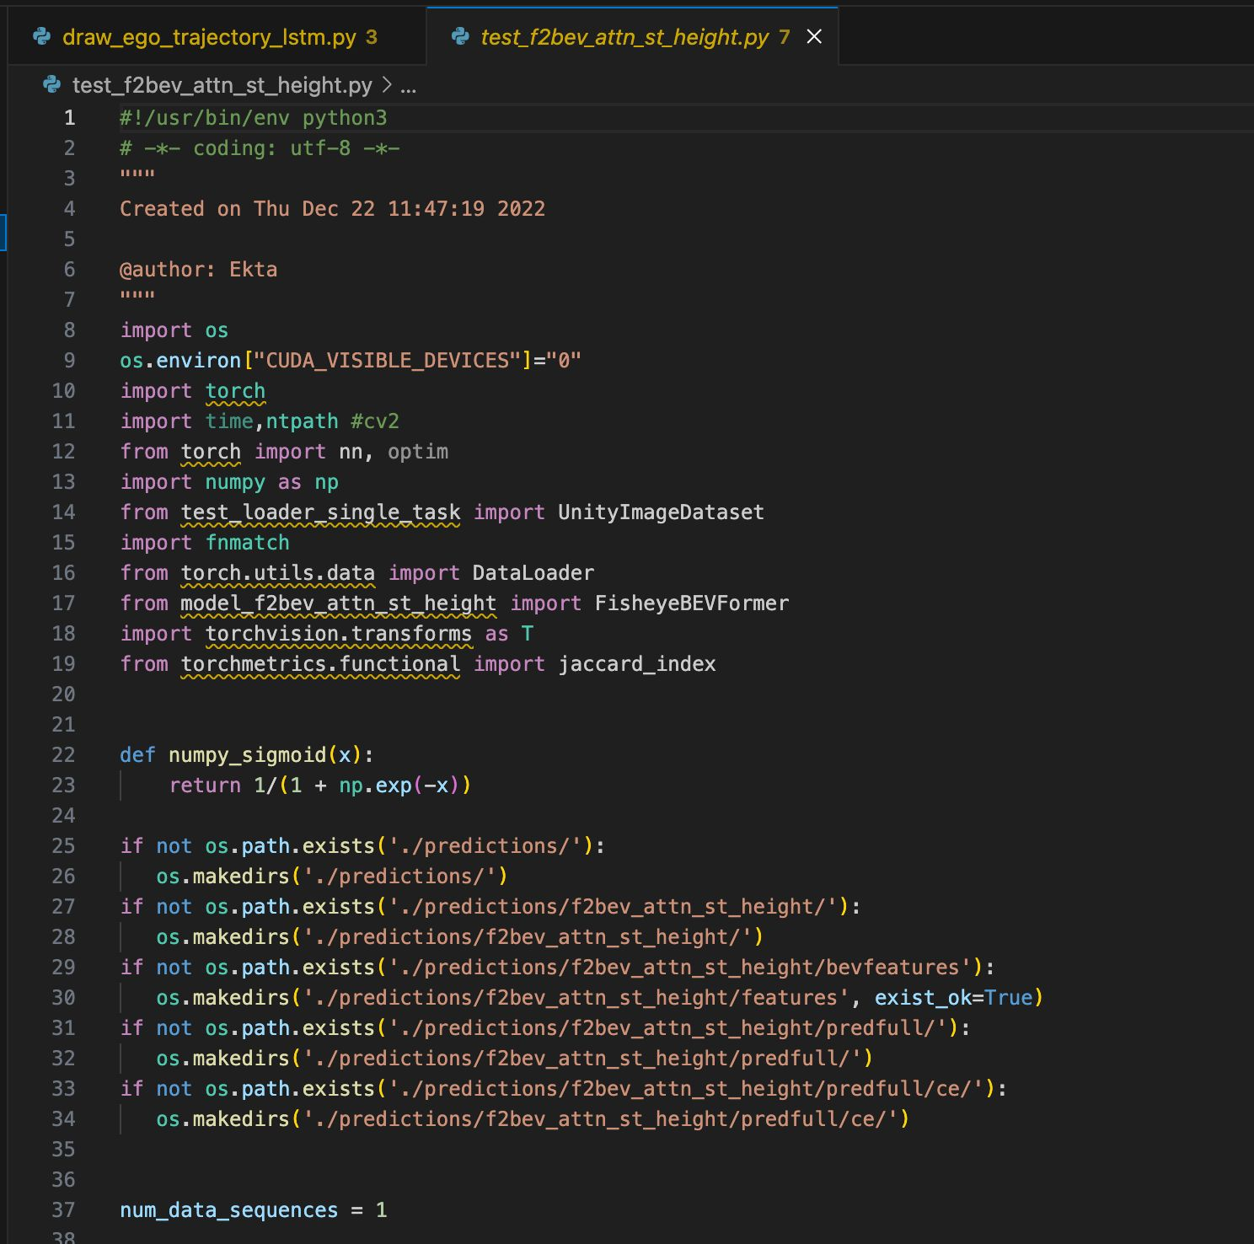
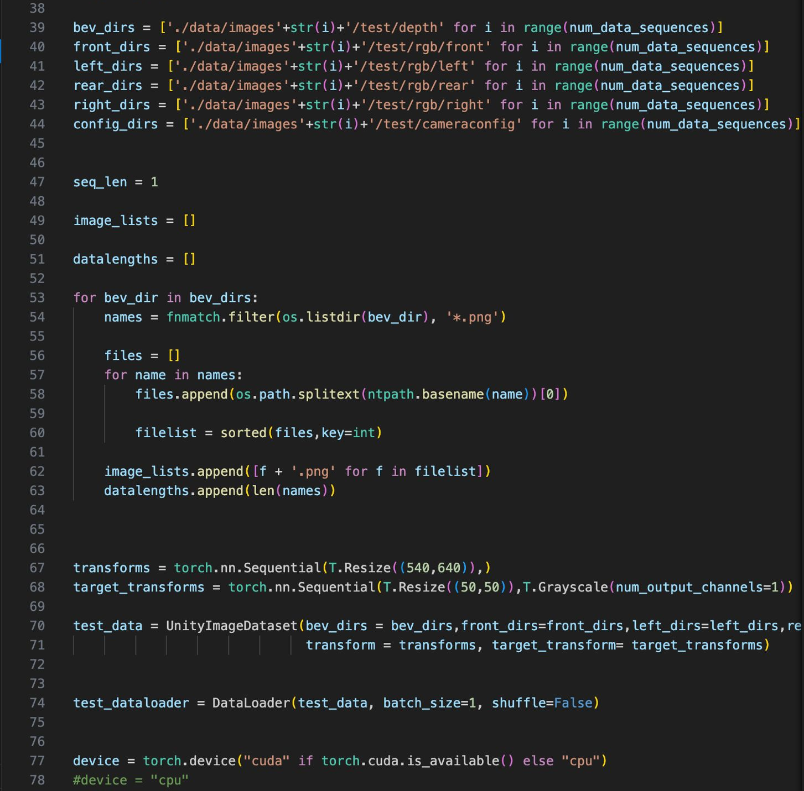

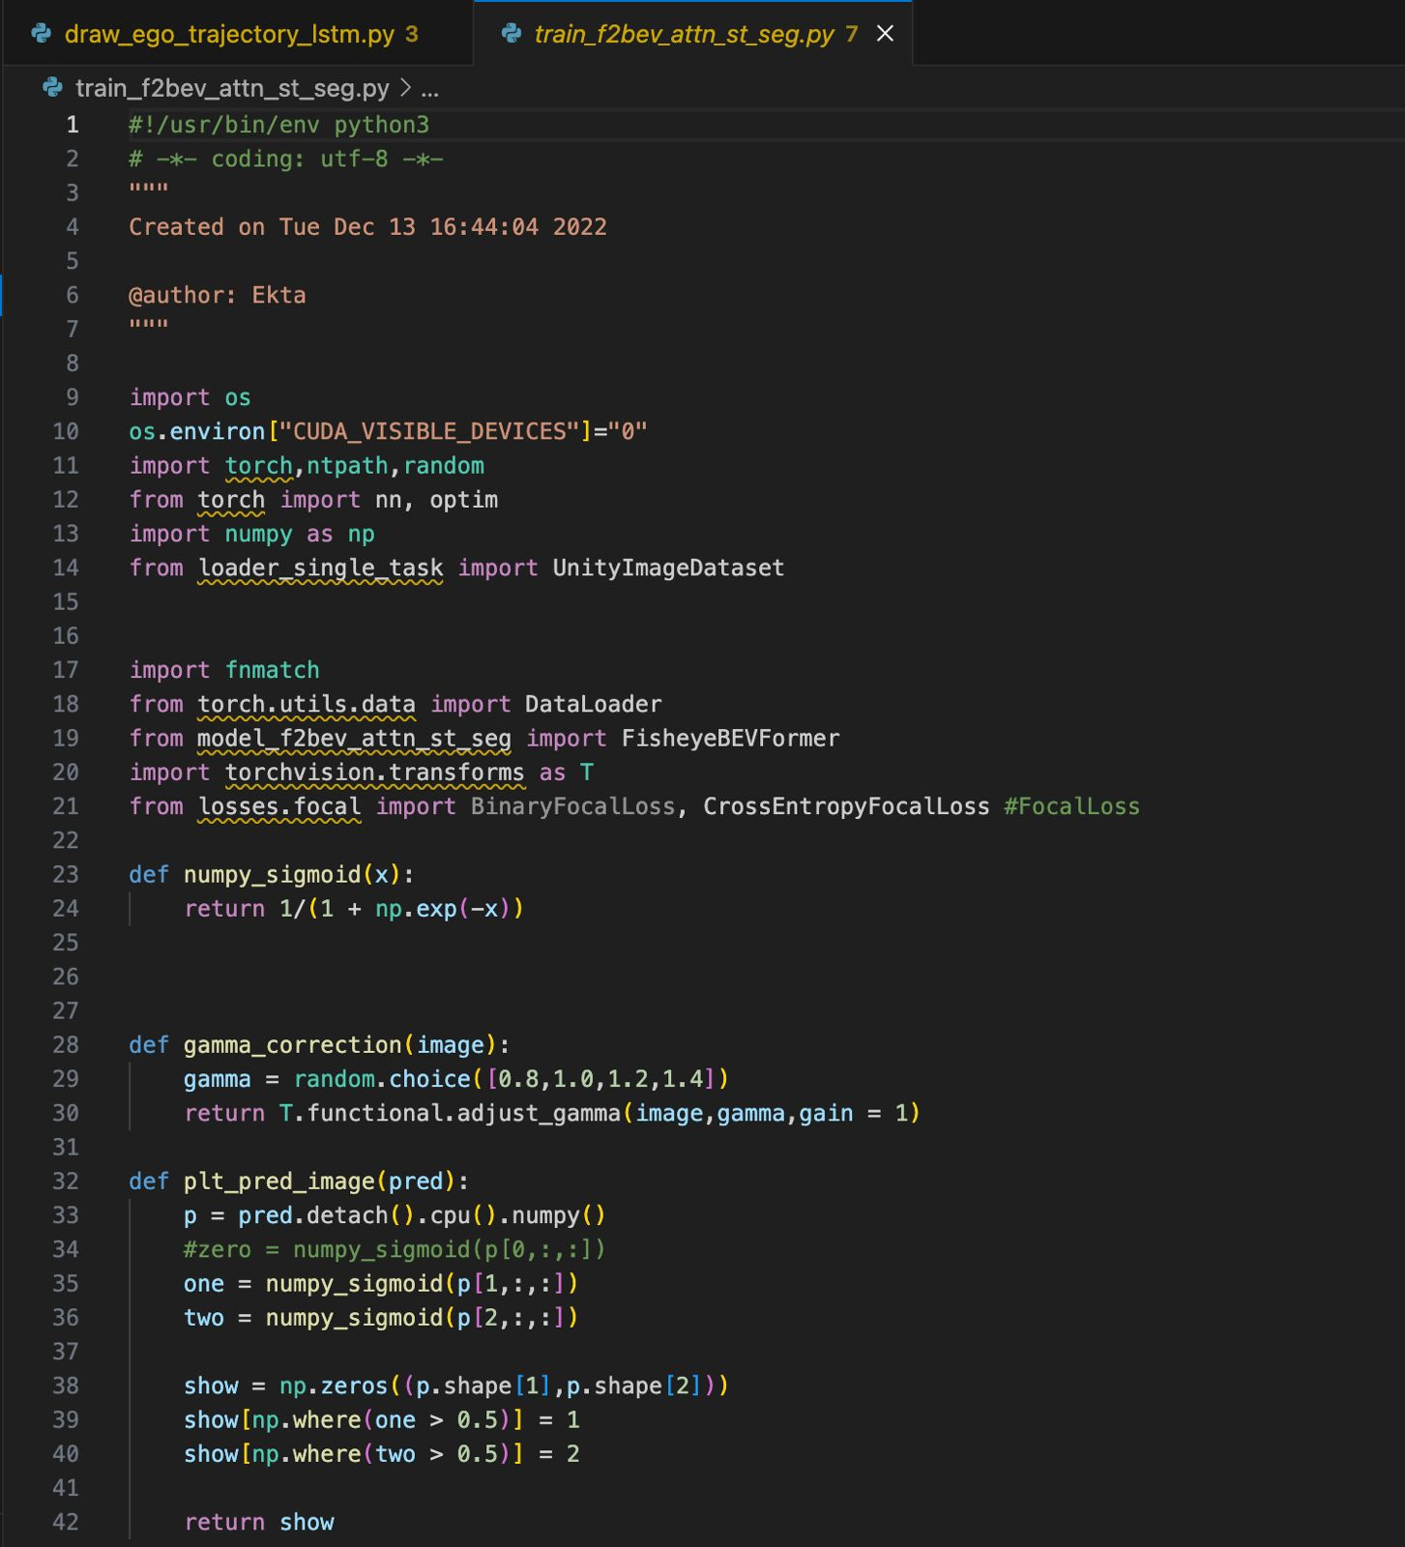

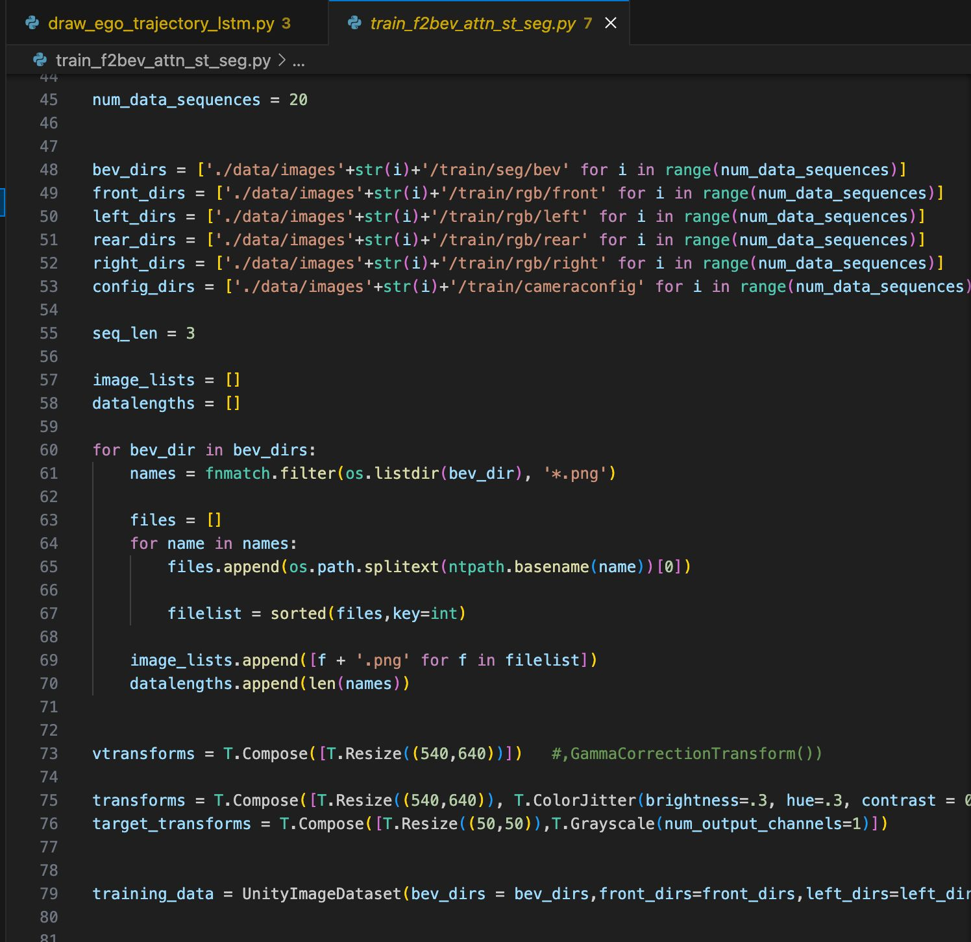

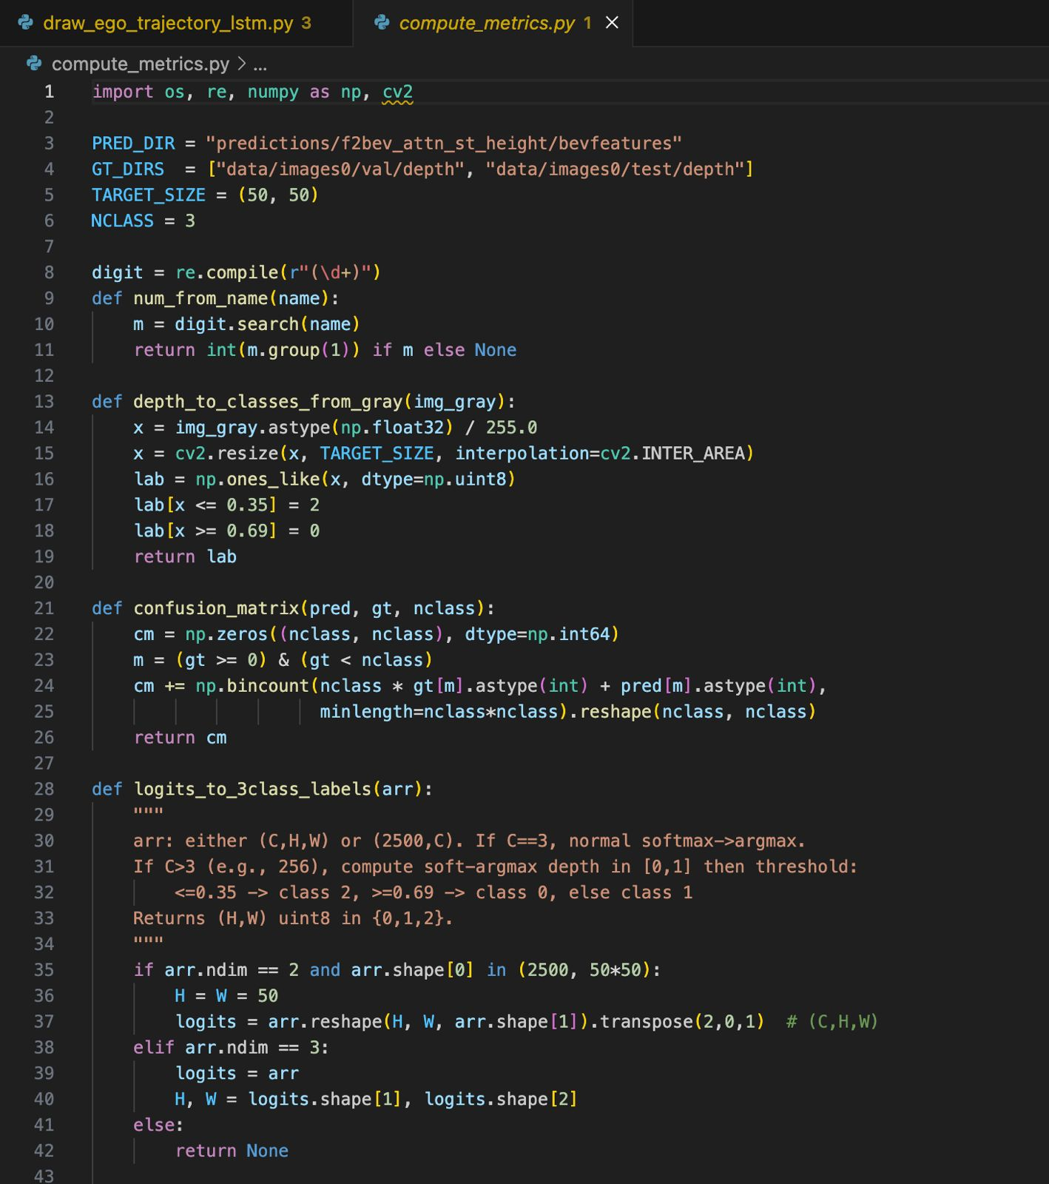

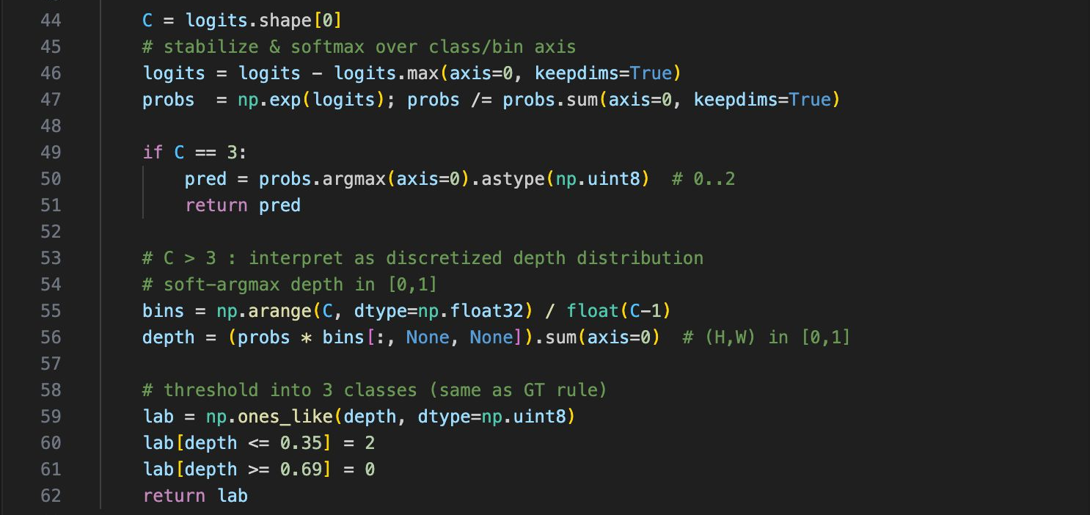

Appendix 2: Weekly progress reports
Week 1:
Understood the problem statement: transforming surround-view fisheye camera images into a Bird's Eye View (BEV) for autonomous driving use. Investigated current literature and datasets (such as FB-SSEM), and realized the challenge in projection, segmentation, and spatial consistency.
Week 2:
Configure the FB-SSEM dataset pipeline. Four camera angle preprocessed images (front, left, rear, right). Configured camera configuration parsing and initialized segmentation targets in depth range bins (Near, Mid, Far). Configured transforms with torchvision.transforms.
Week 3:
Constructed the model architecture with an attention-based variant of F2BEV (FisheyeBEVFormer) for single-task segmentation. Incorporated temporal context through past BEV feature maps. Trained the model using train_f2bev_attn_st_seg.py with CrossEntropy Focal Loss to deal with class imbalance.
Week 4:
Applied test_f2bev_attn_st_height.py to produce segmentation predictions and mid BEV features. Saved .npy outputs for both logits and temporal features. Made sure consistency between train and test pipelines.
Week 5:
Created compute_metrics.py to measure the segmentation predictions. Computed class-wise IoU and mean IoU (mIoU). Discretized ground truth depth into 3 classes:
Class 0 (Far): ≥ 0.69
Class 1 (Mid): 0.35 – 0.69
Class 2 (Near): ≤ 0.35
Achieved:
IoU (Far): 0.75
IoU (Mid): 0.62
IoU (Near): 0.58
Mean IoU: 0.65
Pixel Accuracy: 84.5%
Week 6:
Started implementing ego vehicle trajectory bounding box overlay using OpenCV. Established base draw_ego_trajectory.py for basic overlays and draw_ego_trajectory_lstm.py to predict future trajectories with an LSTM. Incorporated. npy feature maps in order to draw out predicted trajectories.
Week 7:
Experienced difficulties in making LSTM trajectory line turn/bend correctly. Model architecture retains short-term prediction but might require longer sequences or improved feature learning to model dynamic turns. Successfully added bounding box drawing code.
Week 8:
Finalized the segmentation evaluation process and generated all required visual outputs, including semantic BEV maps, overlay visualizations, and prediction results. Successfully integrated all core components: model training (train_f2bev_attn_st_seg.py), testing (test_f2bev_attn_st_height.py), metric computation (compute_metrics.py), and visualization (draw_ego_trajectory.py). Prepared materials for report submission and project demonstration.

